Project: TOOLS IN SIX SIGMA – AN OVERVIEW

By: Sandip Gujar PMP

Admission number: HPGD/JA15/0102

SpecializatioN: OPERATIONS Management

Prin. L.N. Welingkar Institute of Management Development & Research

Year of Submission: DECEMBER 2016

UNDERTAKING BY CANDIDATE

I declare that project work entitled “Tools in Six Sigma - An Overview” is my own work conducted as part of my syllabus.

I further declare that project work presented has been prepared personally by me and it is not sourced from any outside agency. I understand that, any such malpractice will have very serious consequence and my admission to the program will be cancelled without any refund of fees.

I am also aware that, I may face legal action, if I follow such malpractice.


Signature of Sandip Gujar
HPGD/JA15/0102

Acknowledgement

I hereby take this opportunity to express my gratitude to Prin. L.N. Welingkar Institute of Management Development & Research - Prof. Rajesh Aparnath - Head of DLP, Hybrid Programme, the entire Teaching Staff as well as the Non -Teaching Staff of the Institute, FOR actively Guiding ME. I THANK ALL OF THEM for providing HELP, support, cooperation and INSIGHT. I owe acknowledgment and inspiration to www.welingkaronline.org site and all the people behind keeping this site online 365x24x7.

I would also express my indebtness to my family members, friends, and colleagues for their constant support and Ensuring that I take this project to successful completion.

Thank you all for this wonderful Learning experience.

Sandip Gujar PMP®
HPGD/Ja15/0102

Table of Contents
LIST OF FIGURES 6
LIST OF TABLES 7
EXECUTIVE SUMMARY 8
Background 8
Introduction 8
Scope of this Project 11
ProblEm solving Methodlogy – DMAIC 11
Define phase 14
1. Project Charter 15
2. Process Flowchart or Process Maps 16
3. SIPOC Diagram 17
4. Stakeholder Analysis 19
5. DMAIC Work Breakdown Structure 21
6. CTQ Definitions 22
7. Voice of Customer (VOC) 23
Measure phase 24
1. The Process Flowchart or the Process Map 24
2. Data Collection Plan 25
3. Benchmarking 29
5. Measurement System Analysis/Gage R&R 31
6. Voice of the Customer (VOC) 33
7. Process Sigma Calculation 33
ANALYZE PHASE 37
1. Histogram 37
2. Pareto Chart 38
3. Run Chart 40
4. Scatter Plot 43
5. Regression Analysis 44
6. Cause and Effect/Fishbone Diagram 46
7. 5 Whys 47
IMPROVE PHASE 49
1. Brainstorming 49
2. Mistake Proofing (Poka Yoke) 51
3. Design of Experiments 53
4. Pugh Matrix 55
5. Quality Function Deployment (QFD)/House of Quality 56
6. Failure Modes and Effects Analysis (FMEA) 59
7. Simulation Software 62
Control PHASE 66
1. Process Sigma Calculation 66
2. Control Charts (Variable and Attribute) 67
3. Cost Savings Calculations 69
4. Control Plan 71
Recommendations 73
CONCLUSION 75
Mapping this Project Report to Subjects Taught in PGDM – Operations Management 76
Bibliography 77

LIST OF FIGURES
Figure Number | Figure (Graphs, Templates, included) Description  (as is below the figure in this Project Report) | Page Number
1 | DMAIC – General Problem Solving Methodology | 11
2 | DMAIC – Roadmap | 12
3 | DMAIC – Phase-wise details | 12
4 | Guidance Questions to Ask in Define Phase | 14
5 | Sample Project Charter | 15
6 | Example of Process Flowchart or Process Map | 17
7 | Sample SIPOC diagram | 19
8 | Types of Stakeholders | 19
9 | Guidance Questions to Ask in Measure Phase | 24
10 | Example of Process Map | 25
11 | Guidance Questions to Ask in Analyze Phase | 37
12 | Sample Histogram | 38
13 | A Pareto on Complaints Received in a Hotel | 40
14 | Example of Common Cause | 41
15 | Example of Special Cause | 41
16 | Example of Run Chart | 43
17 | Example of Scatter Plot | 43
18 | Types of Regression | 45
19 | Example of Linear Regression | 45
20 | Sample of Fish Bone Diagram | 47
21 | Guidance Questions to Ask in Improve Phase | 49
22 | Prevention & Detection in Poka Yoke | 52
23 | Process Factors and Responses | 54
24 | The Basic Quality Function Deployment Matrix | 58
25 | Details of House of Quality | 58
26 | Sample Quality Function Deployment | 59
27 | Quality Improvement Framework | 63
28 | DMAIC with Simulation Tool | 64
29, | Guidance Questions to Ask in Control Phase | 65
30. | Key Features of a Control Chart | 68
31. | Sample Control Plan | 72

LIST OF TABLES
Table Number | Description  (as is below the table in this Project Report) | Page Number
1 | DMAIC Phases and Tools used | 14
2 | Questions to Ask during SIPOC | 18
3 | Example of Stakeholder Analysis | 21
4 | Data Collection Tools and Techniques | 29
5 | Yield to Sigma Conversion | 35
6 | Example of Pugh Matrix | 56
7 | Example of Cost-benefit Analysis | 71

EXECUTIVE SUMMARY
The project “TOOLS IN SIX SIGMA - AN OVERVIEW” gives an insight of the different tools uses in Six Sigma. In this project I have discussed some tools used in the DMAIC. (DMAIC is an acronym for Define, Measure, Analyze, Improve and Control). The DMAIC process can improve any type of process in any organization, to improve its efficiency and effectiveness. These tools are used to drive quality improvements, within an organization, which is focused around the DMAIC model. Most of these tools used are nothing more than quality methods that have been around for years.
They are used under DMAIC, to bring together years of various process improvement techniques and data analysis, into a structured step by step format, with the aim of finding and eliminating root causes to process problems. Resulting in a more robust process that consistently achieves a high standard of output – one which is capable and in control!
In this project “Tools in Six Sigma – An Overview’ in DMAIC Methodology looks at the Six Sigma project life-cycle with well-defined tools at each stage.

Background
Six Sigma tools are proven to be a powerful enabler for process improvement like:
- CMMI adoption
- Process improvement for measurable ROI
- Statistical analysis

Introduction
- The origins of Six Sigma can be traced back to Johann Carl Frederick Guass, (1777 - 1855) a legendary German mathematician and physicist. In 1818, he started working on the normal distribution which forms the basis of Six Sigma philosophy.
- The person who first coined the term “Six Sigma” was Bill Cohen, an engineer with Motorola. Later, in 1986, Bill Smith, a senior scientist at Motorola, standardized the way in which defects are measured using Six Sigma. Instead of measuring defects in thousands of opportunities, Six Sigma provided the ability to measure defects in millions of opportunities – thereby providing significant improvement in quality.
- Since that time, several companies including Motorola, Citibank, General Electric, Allied Signal, etc. have achieved dramatic success by using Six Sigma methodology for improving quality and reducing costs (for example, Motorola has documented $16 billion in savings because of its Six Sigma efforts).
- There are several factors that make Six Sigma a more effective quality tool when compared with other traditional quality techniques namely:
- Comprehensive
- Project based approach
- Cohesive process based approach
- Quantitative approach
- Commitment from all levels of organization

- Six Sigma is a very comprehensive methodology, which includes the best practices from other traditional quality techniques and tools. The Six Sigma DMAIC Methodology looks at the whole project life-cycle including Define, Measure, Analyze, Improve and Control with well-defined tools and methodology at each stage.
- It links directly to business goals and customer expectations.
- As Six Sigma Methodology is so comprehensive and very well defined, it can be used by
- Companies across different business areas including Manufacturing, Finance, Technology, Construction, Engineering etc.
- Companies of different sizes – big, medium or even small companies with less than 30 employees
- Six Sigma explicitly uses concepts of project management, and so enjoys several benefits of a project i.e. every Six Sigma project has a defined start date and end date, and a pre-defined project charter with goals, objectives and deliverables.
- Project planning tools like project plan, Gantt charts, PERT, planning trees, etc. are used for managing the project and require proper knowledge of different project management knowledge areas.
- Detailed process maps created during the initial stages of a Six Sigma project provide an overview of complex processes in an organization, identify relationships and interdependencies between the processes and facilitate identification of problems.
- The finance department is involved in estimation and validation of project financials and cost benefits from the project.
- Six Sigma methodology can evaluate different aspects within an organization including people, equipment, environment, materials etc. and identify the projects which can provide maximum benefits to the organization.
- Cohesive process based approach helps in getting a holistic view of the organization and identifying potential problem areas
- By using rigorous quantitative and statistical techniques, Six Sigma provides mathematical analysis to determine which project offers the maximum benefit at the least cost i.e. all Six Sigma projects have measurable and quantifiable goals and associated costs.
- Following the quantitative Six Sigma concepts also helps to ensure that:
- The project goals align with the organizational goals
- There are long-term benefits from the Six Sigma project.
- Six Sigma formalizes an organizational structure for Six Sigma projects and ensures commitment from all levels of the organization to achieve the quality goals.
- All the stakeholders – customers, senior management, project team members and other employees have a vested interest in the successful implementation of Six Sigma projects.
- Proper training and motivation is provided to all the people involved in the Six Sigma project to ensure successful project implementation.
- Having a well-defined organization structure helps in creating a feeling of “shared ownership and responsibility” which can be critical in successful project implementation. More importantly, with well defined project hierarchy and pre-defined roles and responsibilities, all Six Sigma stakeholders know their tasks and work towards successful project implementation.
- Six Sigma refers to decreasing the number of defects to 3.4 defects per million opportunities (i.e. success rate of 99.9997%). It attacks variation in processes, minimizing defects and waste, and thereby improving bottom-line.
- Six Sigma philosophy strives towards perfection. The scope of Six Sigma includes tools for careful definition, analysis and measurement of business processes to improve process capability. It relies greatly on statistical techniques to measure and quantify success.
- A lot of emphasis is also put on controlling existing processes to ensure that the processes do not deteriorate over time.
- Six Sigma is a comprehensive quality methodology that can be used to clearly understand an organization’s business processes and customer needs, and either redesign the business processes or provide / make incremental process improvements as desired.
- Some highlights:
- Six Sigma is a business philosophy and top management driven.
- Six Sigma is a problem solving methodology
- Six Sigma is a metric to measure quality and process reliability.
- Six Sigma focuses on both customer and bottom line (profit).
- Six Sigma is a highly quantitative approach to fixing quality problems.
- As the Six Sigma score improves, the variations in the processes reduce drastically, thereby increasing the reliability of the system, which reduces the need for rework.
- The reduction in amount of rework reduces cycle time and improves customer satisfaction
- Six Sigma can be perceived at three levels:
- Metrics: 3.4 Defects Per Million Opportunities (DPMO). DPMO takes the complexity of product or process into account. This should be measured in Critical to Quality (CTQ) characteristics, and not the characteristics of the whole unit.
- Methodology:
- DMAIC (Define-Measure-Analyze-Improve-Control) – structured problem solving road map and tools. This is an improvement system for existing processes falling below specification and looking for incremental improvement.
- DMADV (Define-Measure-Analyze-Design-Verify) – data driven quality strategy for designing product and processes. This is an integral part of a Six Sigma Quality Initiative.
- DFSS (Design For Six Sigma). Unlike the DMAIC methodology, the phases or steps of DFSS are not universally recognized or defined — almost every organization will define DFSS differently. An organization might tailor to suit its business, industry and culture or it might implement the version of DFSS used by the consulting organization assisting in its deployment. DFSS is more of an approach than a defined methodology.
- Philosophy: reduce variation in the business and take customer-focused, data-driven decisions. The philosophy of Six Sigma is to use the framework not only for the process improvement projects, but also for the complete operation of the business. General Electric has used Six Sigma in this way.

Scope of this Project
In this project “Tools in Six Sigma – An Overview”, I have emphasized only on tools that are most frequently used in DMAIC (Define-Measure-Analyze-Improve-Control) phases.

ProblEm solving Methodlogy – DMAIC
- Six Sigma DMAIC Methodology looks at the whole Six Sigma project life-cycle with well-defined tools and methodology at each stage.
- DMAIC methodology lays down tactical steps to achieve Six Sigma quality. The different phases of the DMAIC Methodology are as follows:
- Define
- Measure
- Analyze
- Improve
- Control

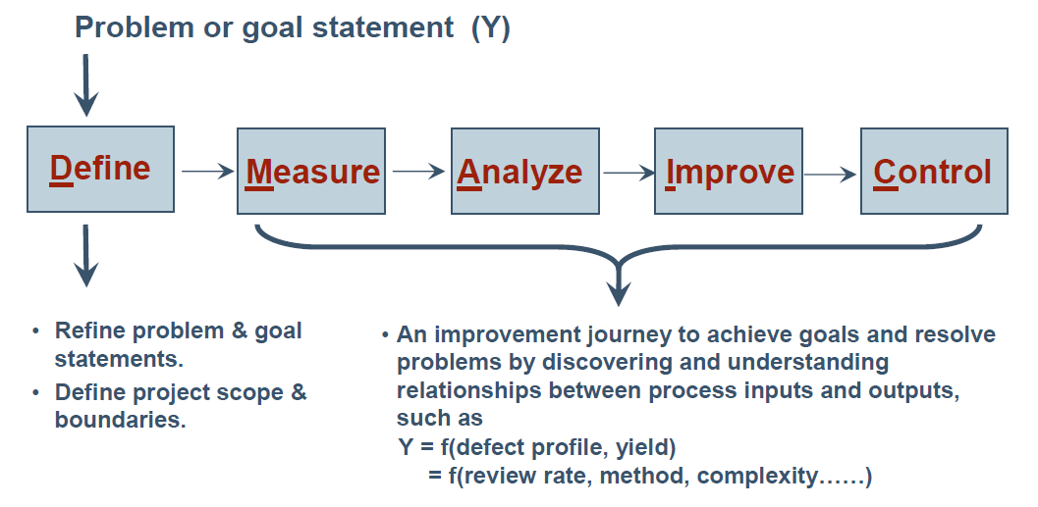
Figure 1: DMAIC – General Problem Solving Methodology
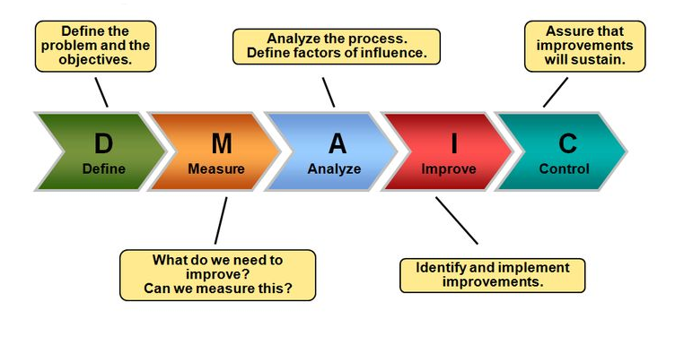
Figure 2: DMAIC – Roadmap

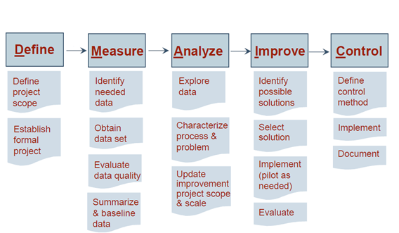
Figure 3: DMAIC – Phase-wise details

- In each phase of DMAIC, there are most utilized Six Sigma tools
DMAIC Phase Steps | Tools Used
D – Define Phase: Define the project goals and customer (internal and external) deliverables.
- Define Customers and Requirements (CTQs)  - Develop Problem Statement, Goals and Benefits  - Identify Champion, Process Owner and Team  - Define Resources  - Evaluate Key Organizational Support  - Develop Project Plan and Milestones  - Develop High Level Process Map | - Project Charter  - Process Flowchart or Process Maps  - SIPOC Diagram  - Stakeholder Analysis  - DMAIC Work Breakdown Structure  - CTQ Definitions  - Voice of the Customer
M – Measure Phase: Measure the process to determine current performance; quantify the problem.
- Define Defect, Opportunity, Unit and Metrics  - Detailed Process Map of Appropriate Areas  - Develop Data Collection Plan  - Validate the Measurement System  - Collect the Data  - Begin Developing Y=f(x) Relationship  - Determine Process Capability and Sigma Baseline | - Process Flowchart  - Data Collection Plan/Example  - Benchmarking  - Measurement System Analysis/Gage R&R  - Voice of the Customer  - Process Sigma Calculation
A – Analyze Phase: Analyze and determine the root cause(s) of the defects.
- Define Performance Objectives  - Identify Value/Non-Value Added Process Steps  - Identify Sources of Variation  - Determine Root Cause(s)  - Determine Vital Few X’s, and Y=f(x) Relationship | - Histogram  - Pareto Chart  - Run Chart  - Scatter Plot  - Regression Analysis  - Cause and Effect/Fishbone Diagram  - 5 Whys
I – Improve Phase: Improve the process by eliminating defects.
- Perform Design of Experiments  - Develop Potential Solutions  - Define Operating Tolerances of Potential System  - Assess Failure Modes of Potential Solutions  - Validate Potential Improvement by Pilot Studies  - Correct/Re-Evaluate Potential Solution | - Brainstorming  - Mistake Proofing  - Design of Experiments  - Pugh Matrix  - QFD/House of Quality  - Failure Modes and Effects Analysis (FMEA)  - Simulation Software
C – Control Phase: Control future process performance.
- Define and Validate Monitoring and Control System  - Develop Standards and Procedures  - Implement Statistical Process Control  - Determine Process Capability  - Develop Transfer Plan, Handoff to Process Owner  - Verify Benefits, Cost Savings/Avoidance, Profit Growth  - Close Project, Finalize Documentation  - Communicate to Business, Celebrate | - Process Sigma Calculation  - Control Charts (Variable and Attribute)  - Cost Savings Calculations  - Control Plan
Table 1: DMAIC Phases and Tools used
- Some Six Sigma tools are used throughout the project, like control plans, cause and effect diagrams, FMEA, process flow charts and others. That is because new ideas may emerge at anytime during the project, factors that were previously thought of as being a big impact to the process may eventually be proved otherwise.
- At each stage, returning to previous steps or methods, helps close off all possibilities and also allows the team to track the history of the project in a concise way.
Let us now Review, Analyze and Interpret the tools as per the stages of DMAIC:
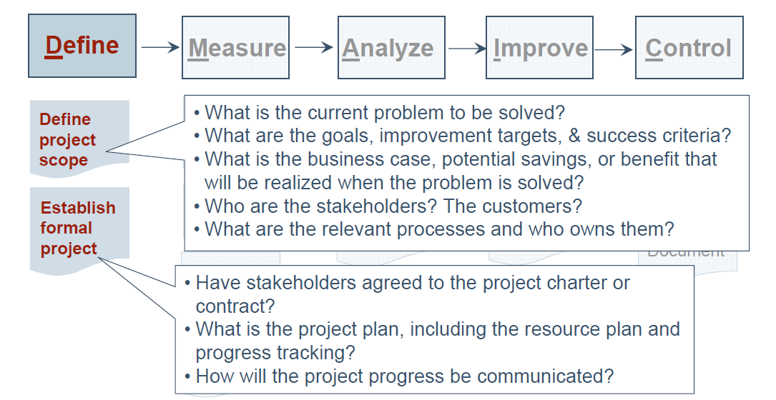 Figure 4: Guidance Questions to Ask in Define Phase
Define phase the tools used to define the project goals and the customer deliveries (internal and external) are:
- Project Charter
- Process Flowchart or Process Maps
- SIPOC Diagram
- Stakeholder Analysis
- DMAIC Work Breakdown Structure
- CTQ Definitions
- Voice of the Customer

1. Project Charter
- A project charter is a document that formally authorizes a project. (As per Project Management Book Of Knowledge - PMBOK ) It includes:
- The business need that the project was undertaken to address
- The product description
- The project charter provides a project manager with the authority to get resources for project activities.
- Creation of the project charter from a Six Sigma project perspective includes several issues that need to be discussed and negotiated by relevant stakeholders.
- Some important points which need to be discussed include:
- Objectives : Quantifiable criteria that must be met for the project to be considered successful
- Scope: This is a measure of the work required to complete the project successfully.
- Boundaries: Project boundary states explicitly what is in scope and what is out of scope of the project
- Resources: While creating the project charter, critical resources (including people and funding required) are negotiated to ensure that appropriate resources are available.
- Project closure activities
- Project transition activities

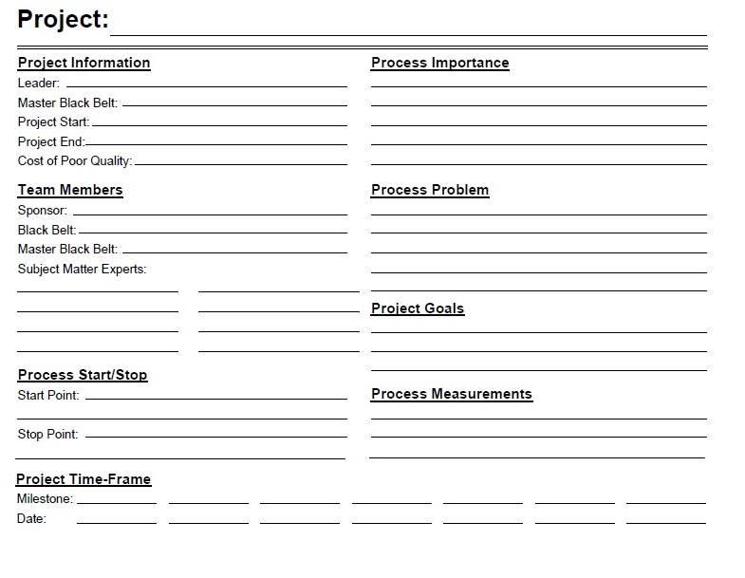
Figure 5: Sample Project Charter
2. Process Flowchart or Process Maps
- A process map takes the process description to a whole new level of understanding. Where verbal descriptions provide the basis of the process, the map identifies the flow of each event in a process. The team can then see whether there is a clear path for a process or whether obstacles exist in the form of rework, cloudy decision points, bottlenecks, etc.
- One of the most interesting aspects of creating a process map in a merged organization is the possibility that the same process in the same department may be described in many different ways. This could be the result of merged organizations not merging processes, processing old information with new tools or processing new information with old tools. It may simply be the diversity of the employees performing the process.
- Features of process maps:
- Process flowcharts or process maps give a view of how work flows through the company. It is a graphic representation of processes in a company showing the sequence of tasks performed and their relationships.
- Standard symbols are used in creation of process maps.
- Process maps are progressively elaborated: i.e. a high level process map is defined early on in the project which shows major processes and this will be made more explicit and detailed as project team develops a better and more complete understanding of all the processes
- Benefits of process maps:
- Helps clarify several process steps and process flow which may not be understood clearly before.
- Helps all members of the team gain appreciation for the work being done by others in the team.
- Visually shows the various alternatives possible and helps in selecting an appropriate solution.
- Symbols used in creation of process maps
- Rectangle: represents a process step or action taken. Each process step has one or more inputs, does some activity, and creates one or more outputs.
- Diamond: represents a decision step i.e. different alternatives possible depending on the input to this step
- Oval: represents the start of stop of a process map, also used to depict if the process map continues in another page
- Arrow: represents the direction of flow in a process map
- Process map - creation steps
- Put together a cross functional team who have knowledge of the process and appropriate subject matter expertise to create the process maps
- Try to find out existing process maps which may already be in existence in the company
- Map all the “As-is” high level processes i.e. processes as they exist now. This will create awareness within the team about the processes in existence currently, and also let all team-members understand the contribution from others. This is the “As-is Process map”
- Ask the cross-functional team to study the process and identify opportunities for improvement.
- Based on the inputs from cross functional team, map all the “To-be” processes. This is the “To be Process map”
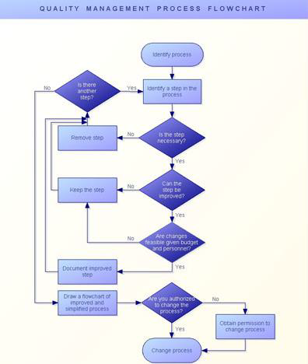 Figure 6: Example of Process Flowchart or Process Map

3. SIPOC Diagram
- First, a quick review of the elements of a SIPOC:
- S (supplier): Entity that provides input(s) to a process
- I (input): All that is used (mostly as variables) to produce one or more outputs from a process. It is worthwhile to note that infrastructure may not be considered as inputs to a steady-state process since any variability induced by such elements remains fixed over longer periods of time
- P (process): Steps or activities carried out to convert inputs to one or more outputs. In a SIPOC, the process steps are shown at a high level.
- O (output): One or more outcomes or physical products emerging from a process.
- C (customer): Entity that uses the output(s) of a process.
- The SIPOC process map is one of the most valuable tools in a Six Sigma professional’s toolbox.
- It typically can be completed with the project team in less than an hour, and has a strong tie to the project charter. It also makes previously unknown customers suddenly appear out of thin air.
- The SIPOC provides an end-to-end picture of a process and is the linchpin of the Define phase The SIPOC diagram is a tool that is typically used in the Define phase of a Six Sigma DMAIC project to identify process outputs and the customers receiving those outputs. Once the customers are identified, voice-of-the-customer data can be collected and customer requirements can be defined.
- The SIPOC diagram also helps scope the project provides a high-level view of the workflow and helps ensure that all team members are seeing the project the same way.
- Understanding an organizational process begins with creating a SIPOC diagram. A SIPOC diagram defines processes at a high level, showing the flow from supplier to customer – whether internal or external. It will provide the foundation for creating detailed process flows and cross-functional swim lane diagrams.
- When creating a SIPOC diagram, a project team does not necessarily begin at the beginning. The team should more likely start in the middle and ask questions about the process itself (P). Next is documenting what is delivered to whom (O and C). Finally, the team can identify what input or information is needed to perform that process (I) and who provides that input (S).
S  Supplier | I  Input | P  Process | O  Output | C  Customer
5 | 4 | 1 | 2 | 3
How does the process start? How does the process end?
Who supplies  what’s needed  to do process? | What is the  input? | What does it  do? | What comes  out of the  process? | What does the  customer get?
Table 2: Questions to Ask during SIPOC
- The tool name prompts the team to consider the suppliers (the‘s’ in SIPOC) of your process, the inputs (the ‘i’) to the process, the process (the ‘p’) your team is improving, the outputs (the ‘o’) of the process, and the customers (the ‘c’) that receive the process outputs. In some cases, requirements of the customers can be appended to the end of the SIPOC.
- The SIPOC tool is particularly useful when it is not clear:
- Who supplies inputs to the process?
- What specifications are placed on the inputs?
- Who are the true customers of the process?
- What are the requirements of the customers?
- Steps to Complete the SIPOC Diagram. SIPOC diagrams are very easy to complete. Here are the steps you should follow:
- Create an area that will allow the team to post additions to the SIPOC diagram.
- Begin with the process. Map it in four to five high level steps.
- Identify the outputs of this process.
- Identify the customers that will receive the outputs of this process.
- Identify the inputs required for the process to function properly.
- Identify the suppliers of the inputs that are required by the process.
- Optional: Identify the preliminary requirements of the customers. This will be verified during a later step of the Six Sigma measurement phase.
- Discuss with project sponsor, champion and other involved stakeholders for verification.

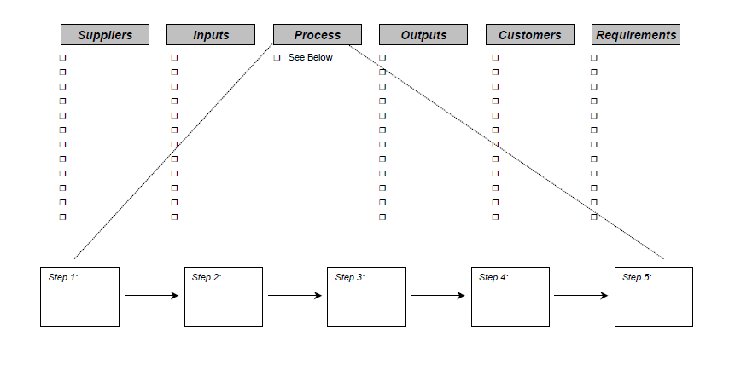
Figure 7: Sample SIPOC diagram

4. Stakeholder Analysis
- Identifies all stakeholders impacted by a project and their anticipated and required levels of support for the project. Typical stakeholders include managers, people who work in the process under study, other departments, customers, suppliers and finance.

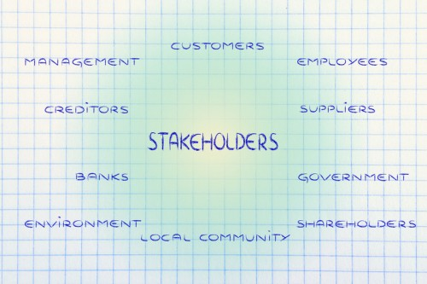
Figure 8: Types of Stakeholders

- The Stakeholder Analysis is a chart which judges the positioning of stakeholders relative to change and commitment to the goals of the team.
- Projects involve change and this often stirs emotions and encounters resistance. The higher the impact of the projected change the more important this tool becomes. The output of the Stakeholder Analysis is a representation of where the impacted people both inside and outside the system stands relative to change.
- It is important that the team starts its journey with team members and stakeholders that minimize resistance to change.
- This tool is commonly used in DMAIC projects throughout the duration especially if it is a longer term project. Its objective is to detect an "out of control" position by a key team member and get it corrected by continually monitoring this behavioral pattern. Those that are not at the level of commitment or willingness to accept change need to be converted.
- This tool is also used as a Project Accelerator. There are a number of techniques to accelerate a project and various tools work depending on the situation. This tool is used to keep track of resources on the team to get the best results in the shortest amount of time.
- Steps to do Stakeholder Analysis
- List all stakeholder names on the team. Other stakeholders are the community, customers, stockholders, but are not included in this exercise.
- Provide a number of 1-5 to indicate their CURRENT and DESIRED willingness to embrace change and make cultural commitment to advocate the change.
- Note that not all members may need to be a 4 or 5, but since a major breakthrough, technical, or cultural change requires a team effort it is important to have the core team neutral or better before starting or proceeding to the next step.
1 = Strong Resistance
2 = Resistance
3 = Neutral
4 = Willing To Change
5 = Strong willingness to accept and embrace change
- Document the roles and the relationships members that impact one another, boss, co-worker, material handler, and operators.
- Develop a plan to get individuals to desired rating quickly. If the plan is not working the person may need to be replaced before proceeding.
- The Stakeholder Analysis tool may be used at any time during any phase to gauge the member's positioning. Overuse might indicate a trust issue within the team.

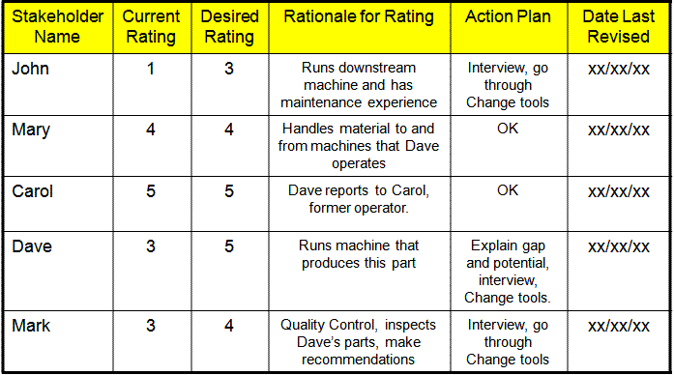 Table 3: Example of Stakeholder Analysis

5. DMAIC Work Breakdown Structure
- There have been instances when Six Sigma projects have failed due their unmanageable size. Therefore, it is important that such projects are broken down into several smaller projects, a process which is technically referred as Work Breakdown Structure (WBS).
- Breaking projects down into manageable projects helps ensure that all are undertaken carefully, which is important for the overall success of projects.
- The WBS Approach:
- The WBS approach provides Six Sigma teams with tools and techniques that would allow a breaking down of the project without compromising on project objectives.
- WBS aims to achieve results that will occur after integrating results of smaller sub projects. The sub-projects and scheduling is done so that the same team manages them without having to expend any additional resources.
- WBS also provides for problem-free breakage of work schedules and targets without having to expend extra resources on hiring new Six Sigma professionals or investing in new systems and technologies. This way, organizations are able to utilize their existing resources to their fullest, while getting the benefits of Six Sigma projects at the same time.
- This enables the organization to achieve objectives of the bigger project with optimal utilization of resources.
- WBS Process:
- This WBS process starts with defining the nature and scope of various subprojects and how they are interrelated to each other. However, achieving this is often not easy because it is quite complex and a little mistake on part of the Black Belt can severely affect the successful implementation of the project.
- The standard breaking-down process is achieved by employing Six Sigma DMAIC tools and methodologies such as decompositions and integrations as the team breaks down the process; they have to integrate the sub-projects to achieve the expected results.
  - These work packages are specifically assigned to one person or one team of people for completion. A project that is broken down using WBS has its own WBS dictionary, which has a detailed description of each component of the WBS.
  - Though WBS proves to be very useful for making huge projects manageable, it should not be too detailed, as that may lead to the slowing down of the entire project.
  - Remember that WBS is not a plan or schedule – and thus, not a replacement for project plans. It is important that teams do not list out the tasks to done in a WBS, but deliverables of the project.
- Project Deliverables
- As a part of the Six Sigma project, the project deliverables as stated by the project mission statement are also of high relevance. It is very difficult to measure and track these deliverables.
- Breaking them into smaller parts makes it difficult to obtain their time and cost estimates. WBS enables the breaking down of these deliverables into measurable and manageable components. Though there will be separate handling of each deliverable, WBS and the WBS dictionary make it easier, so that integrating them gives the expected results.
- Sometimes, it is not possible to have the minutest of details of deliverables for WBS. It is, however, possible to create a short-term plan known as Rolling Wave Planning. This allows teams to plan until they details about the plan; then, when the details are available, they can plan further.
- The basic aim of DMAIC WBS is to ensure the successful implementation of a large Six Sigma project. Although standard WBS tools are available, Black Belts can also use their creativity and experience for breaking large projects into smaller subprojects. Whatever be the procedure employed, one thing is certain that without WBS, none of the large Six Sigma projects would have ever been successfully implemented.

6. CTQ Definitions
- The first step to clearly define what the customer wants as an explicit requirement, these requirements are CTQ (Critical-to-Quality)
- CT stands for ‘critical to’ whatever matters. Depending on what one is analysing and optimising, this could mean anything from the satisfaction of the customer, to the quality and reliability of the product, to the cycle time of manufacture or the cost of the delivered product or service.
- Most CT trees begin with the output of the SIPOC, customer satisfaction at the top and the others being subordinate. Following CTXs are most commonly used:
- Satisfaction (CTS): What contributes to customer success?
- Quality (CTQ): What contributes to process or product quality?
- Cost (CTC): What contributes to the cost or final price?
- Delivery (CTD): What contributes to the cycle time to deliver?
- CTQs are the elements that are critical to meeting customer needs or simply those characteristics of your product or service that are critical to quality. CTQs can apply both to the end customer, as well as internal customers.
- Determining CTQs is all about the conversion from the voice of the customer to measurable requirements—taking the verbatim comments of customers and translating them into product features that will meet their needs.
- Often times, when you ask customers what’s important to them, they answer in a way that provides a hint to what the need is, but may not be the true need. They may answer in the form of a solution, or state a problem, and so the goal of the design team becomes determining what the underlying need is that prompted that response.
- All CTQs must be converted to measurable terms that can be quantified by the design team so the organization knows if the needs are being met. If you can quantify, then you’ve got a way to measure your ability to meet that customer need.
- In order for any process capability to accurately be calculated, one must properly define and quantify the process defect, unit and opportunity. Every process should have definitions for defect, unit and opportunity. The following sections are important:
- Start With The Customer
- Define Your Product/Service Defects
- Define Your Product/Service Units
- Define Your Product/Service Opportunities
- CTQ Examples Including Defect, Unit and Opportunity

7. Voice of Customer (VOC)
- The voice of the customer (VOC) is the feedback from your current and future customers indicating service offerings that satisfy, delight, and dissatisfy them.
- You can obtain the voice of the customer through many different ways, including surveys, focus groups, interviews, listening posts, and mystery shopping.
- Benefits of VOC:
- Helps you focus on those items that are most valuable to your current customers
- Identifies gaps in the services you provide to the customer
- Allows you to focus on those items that will be most valuable to future customers
- Identifies potential improvement opportunities and the associated priorities from a customer viewpoint
- Allows you to decommission services that are of little or no value to your customers or future customers
- How to Use VOC:
- Step1.Identify your customers and your future customers. The customers you want to have in five years may be different than the customers you have today.
- Step2.Determine the tools and techniques you will use to gain feedback from your target customers. Surveys, focus groups, and interviews are popular tools used to gather the information.
- Step3.Incorporate the results of your data gathering and analysis into your service offerings, making continual improvements as appropriate.
- Step4. Develop a schedule to reassess your customers on an ongoing basis to ensure your service offerings meet or exceed their requirements.

After completing visiting the tools in the Define phase we now move on to review, analyze and interpret tools in the Measure Phase.

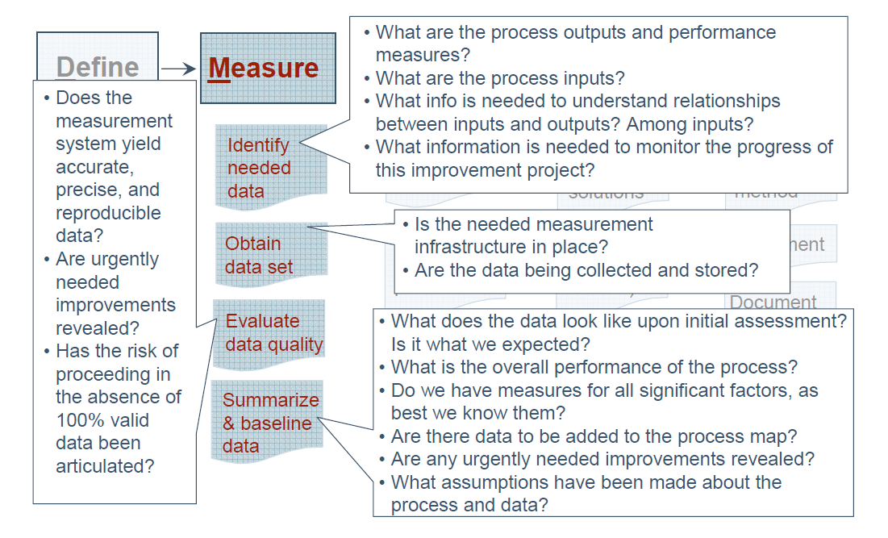
Figure 9: Guidance Questions to Ask in Measure Phase

Measure phase we determine current performance and quantify the problem using tools like:
- Process Flowchart or Process Map
- Data Collection Plan/Example
- Benchmarking
- Measurement System Analysis/Gauge R&R
- Voice of the Customer
- Process Sigma Calculation

1. The Process Flowchart or the Process Map
- Graphic display of the flow or sequence of events that a product or service follows; it shows all activities, decision points, rework loops, and handoffs.
- A project team creates the first of several process maps. A process map is a picture of the current steps in the process targeted for improvement.
- A process map has five major categories of work from the identification of the suppliers of the process, the inputs the suppliers provide, the name of the process, the output of the process, and the customers of the process.
- Each of these steps is summarized as SIPOC to indicate the steps to the team that must be conducted to complete a process map.
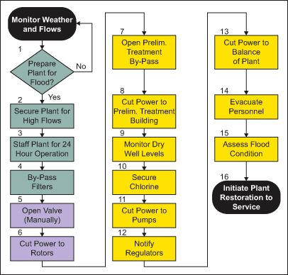 Figure 10: Example of Process Map

2. Data Collection Plan

- Six Sigma practitioners who are leading DMAIC (Define, Measure, Analyze, Improve, and Control) projects should develop a data collection plan in order to gather data in the measurement phase.
- A data collection plan is prepared to collect the required data. This plan includes what type of data needs to be collected, what are the sources of data, etc. The reason to collect data is to identify areas where current processes need to be improved.
- You collect data from three primary sources: input, process, and output.
- The input source is where the process is generated.
- Process data refers to tests of efficiency: the time requirements, cost, value, defects or errors, and labor spent on the process.
- Output is a measurement of efficiency.
- A detailed checklist with responses can help to bring out the importance of building a well-defined data collection plan prior to execution.
- There are several crucial steps that need to be addressed to ensure that the data collection process is stable and reliable. Incorporating these steps into a data collection plan will improve the likelihood that the data and measurements can be used to support the ensuing analysis. A brief description of these steps follows.
- Three phases – six steps – are involved in building up a data collection plan:
- Pre-Data Collection Steps
- 1. Clearly define the goals and objectives of the data collection
- 2. Reach understanding and agreement on operational definitions and methodology for the data collection plan
- 3. Ensure data collection (and measurement) repeatability, reproducibility, accuracy and stability
- During Collection Steps
- 4. Follow through with the data collection process
- Post-Data Collection Steps
- 5. Follow through with the results
- Step 1: Define Goals And Objectives
    - A good data collection plan should include:
  - A brief description of the project
  - The specific data that is needed
  - The rationale for collecting the data
  - What insight the data might provide (to a process being studied) and how it will help the improvement team
  - What will be done with the data once it has been collected
  - Being clear on these elements will facilitate the accurate and efficient collection of data.
- Step 2: Define Operational Definitions and Methodology
- The improvement team should clearly define what data is to be collected and how.
- It should decide what is to be evaluated and determine how a numerical value will be assigned, so as to facilitate measurement.
- The team should consider consulting with the customer to see if they are already collecting the same (or similar) data. If so, comparisons can be made and best practices shared.
- The team should also formulate the scope of the data collection:
  - How many observations are needed
  - What time interval should be part of the study
  - Whether past, present, and future data will be collected
  - The methodologies that will be employed to record all the data
    - It is best to obtain complete understanding of and an agreement on all the applicable definitions, procedures and guidelines that will be used in the collection of data.
    - Overlooking this step can yield misleading results if members of the improvement team are interpreting loosely defined terms differently when collecting data. Serious problems can arise for the organization when business decisions are made based on this potentially unreliable data.
    - If the team wishes to examine historical data to include as part of the study, careful attention should be paid to how reliable the data and its source has been, and whether it is advisable to continue using such data. Data that proves to be suspect should be discarded.
- Step 3: Ensuring Repeatability, Reproducibility, Accuracy and Stability
    - The data being collected (and measured) will be repeatable if the same operator is able to reach essentially the same outcome multiple times on one particular item with the same equipment.
    - The data will be reproducible if all the operators who are measuring the same items with the same equipment are reaching essentially the same outcomes.
    - In addition, the degree to which the measurement system is accurate will generally be the difference between an observed average measurement and the associated known standard value.
    - The degree to which the measurement system is stable is generally expressed by the variation resulting from the same operator measuring the same item, with the same equipment, over an extended period.
    - Improvement teams need to be cognizant of all the possible factors that would cause reductions in repeatability, reproducibility, accuracy and stability – over any length of time – that in turn may render unreliable data.
    - It is good practice to test, perhaps on a small scale, how the data collection and measurements will proceed. It should become apparent upon simulation what the possible factors are, and what could be done to mitigate the effects of the factors or to eliminate the factors altogether.
- Step 4: The Data Collection Process
    - Once the data collection process has been planned and defined, it is best to follow through with the process from start to finish, ensuring that the plan is being executed consistently and accurately.
    - Assuming the project lead has communicated to all the data collectors and participants what is to be collected and the rationale behind it, he or she might need to do additional preparation by reviewing with the team all the applicable definitions, procedures, and guidelines, etc., and checking for universal agreement.
    - This could be followed up with some form of training or demonstration that will further enhance a common understanding of the data collection process as defined in the plan.
    - It is a good idea that the Black Belt or project lead be present at the commencement of data collection to provide some oversight. This way the participants will know right away whether or not the plan is being followed properly.
    - Failure to oversee the process at its initial stages might mean that a later-course correction will need to be made, and much of the data collection and/or measurement efforts will be wasted.
    - Depending on the length of time it takes to collect data – and whether the data collection is ongoing – providing periodic oversight will help to ensure that there are no shortcuts taken and that any new participants are properly oriented with the process to preserve consistency.
- Step 5: After The Data Collection Process
    - Referring back to the question of whether or not the data collection and measurement systems are reproducible, repeatable, accurate, and stable, the Black Belt or project lead should check to see that the results (data and measurements) are reasonable and that they meet the criteria.
    - If the results are not meeting the criteria, then the Black Belt or project lead should determine where any breakdowns exist and what to do with any data and/or measurements that are suspect.
    - Reviewing the operational definitions and methodology with the participants should help to clear up any misunderstandings or misinterpretations that may have caused the breakdowns.
- Step 6: Sample Populated Data Collection Plan
    - In order to create your own data collection plan, you should follow an outline and reproduce with your project specific plan.
- For Example: When insurance companies invest in the right kinds of data collection, the results can be impressive. Consultants have seen teams who have reduced the cycle time of critical process steps such as inspection and payment by as much as 50 percent and cut costs-per-claim by at least 10 to 20 percent. This reduction in cycle times can quickly add up to millions of dollars in direct savings. Without the right data, however, teams will not know how much improvement was needed to meet customer requirements and which parts of the process are keeping them from meeting those requirements.
 | Continuous data (Variables) | Discrete data (Attributes)
Definition | - This is information that can be measured on a continuum or scale e.g.  - Weight of packages sent  - Customer wait time for every customer service call  - Average speed of cars traveling in a highway | - This is a whole number (or count) of attributes like :  - Number of people buying a product  - Number of defects per 1000 events  - Number of satisfied customers
Identification | To identify continuous data, ask the question whether the data can be expressed to any desired level of precision or decimal point e.g. What is the distance covered by the car? This can be answered as 1 mile, 1.1 miles, 1.1.1 miles etc. Any data that can be measured to any desired level of precision is called continuous data. | To identify discrete data, ask the question whether the data can be expressed by 1 level of precision e.g. Is your age equal to or greater than 35 years? This can be answered as Yes or No. There is no further level of precision possible. So, the data type is discrete
Tools used | Data collection: Demographic questions (e.g. age etc.), fill-in-the-blank questions (e.g. distance covered, temperature, humidity etc.) | Data collection: Ranking, Rating, Yes/No questions mostly on Stakeholders, Customers and financial measures
Table 4: Data Collection Tools and Techniques

3. Benchmarking
- Benchmarking is a technique, in which an organization measures its performance against that of best in class organizations, determines how those organizations achieved their performance levels and use the information to improve its own performance.
- Benchmarking is the process of measuring products, services, and processes against those of organizations known to be leaders in one or more aspects of their operations.
- Benchmarking provides necessary insights to help you understand how your organization compares with similar organizations, even if they are in a different business or have a different group of customers.
- Additionally, benchmarking can help you identify areas, systems, or processes for improvements—either incremental (continuous) improvements or dramatic (business process reengineering) improvements.
- Benchmarking is not just a matter of making inquiries to other organizations or touring and documenting another organization’s facilities or processes. When making use of benchmarking, an organization should not limit the scope to its own industry, nor should benchmarking be a one-time event.
- Benchmarking can be classified into three categories – internal, competitive and strategic.
- Internal benchmarking is used when an organization already has established and proven best practices and they simply need to share them. Again, depending on the size of the organization, it may be large enough to represent a broad range of performance (i.e., cycle time for opening new accounts in branches). Internal benchmarking also may be necessary if comparable industries are not readily available.
- Competitive benchmarking is used when an organization wants to evaluate its position within its industry. In addition, competitive benchmarking is used when an organization needs to identify industry leadership performance targets.
- Strategic benchmarking is used when identifying and analyzing world-class performance. This form of benchmarking is used most when a company needs to go outside of own industry. Six Sigma often uses Hoshin to ensure that all employees are knowledgeable about the strategic direction for the organization. Within an organization’s Hoshin plan, goals are established relative to benchmarks set by world-class organizations. Often, these benchmarks are obtained from outside industries.
- Steps Involved in Benchmarking
It is important that Six Sigma practitioners have a thorough understanding of their own organization’s guidelines before undertaking a benchmarking opportunity. The following is a list of the vital few steps involved in benchmarking. These steps should be tailored based on the organization’s policies, resource availability and the project or process one is dealing with:
1. Understand the organization’s current process performance gaps. This will help decide what needs benchmarking.
2. Obtain support and approval from the executive leadership team (top management). That approval and support will assist in eliminating roadblocks, providing adequate resources and expediting the benchmark-gathering process.
3. Document benchmarking objectives and scope. This is a necessity for any project.
4. Document the current process. Without up-to-date knowledge of the current process:
a. Time and resources can be wasted collecting process documentation and data that already exists.
b. The project may lack focus, purpose and/or depth.
c. Benchmarking visits may appear to be random exercises in information-gathering.
d. The team could select a partner whose performance is actually worse than that of its own organization.
e. Collected benchmarking data will be difficult to compare “apples to apples” in terms of process requirements.
5. Agree on the primary metrics. Benchmarking measurements are used as the basis of many comparisons:
a. To determine the gap between current performance and that of partner organizations.
b. To track progress from the present (with the current process) into the future.
c. To track partners’ progress toward their goals.
d. To determine superior performance with process improvements.
e. To use a measurement systems analysis (MSA):
        - These comparisons will be valid only if everyone participating in the study measures performance in exactly the same way – every time.
        - It is important to make sure metrics are being established that potential benchmarking partners are probably already tracking or that can be easily derived from existing measurements.
6. The metrics should be put in writing. In particular:
a. What is being measured?
b. How the units of measure will be classified?
c. What should be included in the measurement?
d. What should not be included?
e. How to make any necessary calculations?
f. Examples of typical measurements.
7. Agree on what to benchmark. Everyone must be in agreement on what to benchmark prior to any benchmark gathering initiative in order to:
a. Understand gaps of low performers.
b. Understand impact to customers, associates and shareholders.
c. Prioritize and select one to three metrics to benchmark.
8. Develop a data collection plan.
9. Identify research sources and initiate data gathering.
10. Design a screening survey to assist with partner selection. Characteristics of the survey are important:
a. Crisp focus on indicators of excellence
b. Two pages maximum
c. 30 minutes maximum to complete
d. Objective, multiple-choice questions
e. Communicates the plans, objectives and resource requirements for the study
f. Reflects focus areas for subsequent in-depth questionnaires
11. Determine how to contact and screen organizations.
12. Design a detailed survey to gather information.
13. Decide if gathered information meets original objectives.
14. Conduct a site visit.

5. Measurement System Analysis/Gage R&R

- Measurement systems analysis is the practice of determining the extent to which observed process variation is due to variation in the measurement systems.
- Measurement system errors are classified into two broad categories: Accuracy and precision. With most measurement systems, both errors are present.
- Accuracy is the difference between the observed measurement and the true value. Linearity, Bias and Stability are the three sources that contribute to the accuracy error. Gauge Linearity, Gauge Bias and Gauge Stability studies help in analysing measurement systems accuracy issues.
- Precision error is the condition of observing variation from measurement to measurement, or from part to part. Repeatability and Reproducibility are two components of precision error.
- Components that might be included in Measurement System Analysis are precision-to-tolerance ratios, measurement capability indices (Cpk for measurement system capability), procedures, plans or protocol, and summary reports.
- There has been some critical review, particularly of summary metrics such as Gage repeatability and reproducibility (GR&R) and percent tolerance (also known as precision-to-tolerance ratio) and what are considered acceptable values.1,2,3
- Gage R and R (repeatability and reproducibility) studies help in determining the extent to which device and process variation contribute to overall measurement system variation. Gage R&R can be applied to any kind of measurements (attribute or variables, indeterminate or determinate).
- In industries such as medical devices, measurement system analyses can influence decisions that can critically affect the lives of patients. Consequently, the impact of measurement system analyses on decision making, as related to the probability of misclassification, is of vital importance.
- Precision describes the relative spread in measured values for a common item. The precision of a measurement system is commonly assessed using a GR&R.
- GR&R studies quantify gage variance, and this variance can be compared to a targeted measurement range. The range may encompass the variability observed over the GR&R study, the variability of a separate population or a specification interval. In each case, a gage is generally considered precise enough when gage variation is small compared to the measurement range of interest.
- A GR&R study is a designed experiment in which factors influencing gage variance are studied using a full factorial design.
- GR&R studies typically include two factors:
      - a random factor representing parts and
      - a factor influencing measurement variation (operator is commonly chosen as the second factor).
- Additional factors may be added, where each factor may represent additional sources of variation. These additional factors may include measurement instruments, environment, etc.
- A GR&R study can identify contributions to gage variance in terms of repeatability and reproducibility based on the factorial structure of the controlled experiment.
- Repeatability describes the contribution to gage variance from a measurement system when the same part is measured multiple times with all other factors held constant.
- Reproducibility describes the relative contribution to gage variance from additional factors and interactions between additional factors and parts:
- Gage error can be estimated using random-effects analysis of variance methods provided certain assumptions can be met:
- Gage error and measured values are independent.
- The values chosen for measurement in a gage study were drawn from large populations.
- The underlying populations are normal.
- The GR&R study is balanced with sufficient power based on the number of factors.
- Gage performance is commonly defined by comparing the relative percentage that gage error consumes over a measurement range. Three different percentages can be readily calculated using gage standard deviation (σ g):
- Percent study variation
- Percent process
- Percent tolerance
- In each of these cases gage precision is established by comparing gage variation to a measurement range of interest. When the gage precision error is small compared to the measurement range of interest, the gage is well suited to differentiate or compare measured values within the range.
- Gage R&R statistically isolates different types of variation in the measurement process. These types of variation include:
  - Repeatability = equipment variation = within variation
  - Reproducibility = appraiser variation = between variation
  - Residual or pure error
  - Variation due to interaction effects.
- For example, out of several inspectors, one might have a tendency to read one gage differently than others
- There are many overlapping methods outlined in the literature that can be used to perform Gage R&R. A few of these methods are as follows:
- Analysis of variance (ANOVA) method
- Average and range method
- Within part variation (WIV) method
- Automotive industry action group (AIAG) method
- The two most common method types used and supported by statistical software are the ANOVA method and the average and range method.

6. Voice of the Customer (VOC)
- It is a systematic approach to gather and analyze customer requirements, expectations, level of satisfaction and dissatisfaction through complaints, surveys, comments, market research, focus groups and interviews.
- The customer is the most important stakeholder for any company, and so it is extremely important to understand the customer needs and aspirations.
- Voice of the customer refers to the stated or unstated needs of the customer, which should be understood very well before designing any product or service.
- Customers who purchase the organization’s products or services also provide feedback regarding a set of attributes they use to compare one competitor to others.
- VOC is the final source of critical requirements, which become performance targets for the enterprise’s processes.
- There are 3 steps that need to be followed to understand the voice of the customer:
- Identify the customer
- Collect and analyze customer data
- Determine critical requirements

7. Process Sigma Calculation

Now, let’s discuss few definitions to understand the process sigma calculation
- Unit
- A unit is the item (e.g., product or component, service or service step or time period) to be studied.
- A unit is any item that is produced or processed which is liable for measurement or evaluation against predetermined criteria or standards.
- A non-conforming unit is a defective unit.
- Opportunity
- Any area within a product, process, service, or other system where a defect could be produced or where you fail to achieve the ideal product in the eyes of the customer.
- In a product, the areas where defects could be produced are the parts or connection of parts within the product.
- In a process, the areas are the value added process steps. If the process step is not value added, such as an inspection step, then it is not considered an opportunity.
- Opportunities are the things which must go right to satisfy the customer. It is not the number of things we can imagine that can go wrong.
- Total Opportunities (TO)
- TO = Total number of Product Units x Opportunities
- Defect
- A defect is a non-conformance on one of many quality characteristics of a unit that causes customer dissatisfaction. Each defect for a unit needs to be operationally defined.
- Any type of undesired result is a defect..A failure to meet one of the acceptance criteria of your customers. A defective unit may have one or more defects.
- ‘A defect is a failure to conform to requirements’ (Phil Crosby, ‘Quality Is Free’), whether or not those requirements have been articulated or specified. The non-conformance to intended usage requirement.
- It is any instance or occurrence where the product or service fails to meet customer requirements.
- Defect Opportunity
- A defect opportunity is each circumstance in which a CTQ can fail to be met. There may be many opportunities for defects within a defined unit. The number of defect opportunities is generally related to the complexity of the unit.
- Defects per Unit (DPU)
- It refers to the average of all defects for a given number of units
Total Number of Defects
- DPU = ----------------------------------------
Total number of Product Units
- Defects per Opportunity (DPO)
- DPO refers to the number of defects divided by the number of defect opportunities.
Total Number of Defects /
- DPO = -------------------------------------
Total Opportunity
- Defects Per Million Opportunity (DPMO)
- DPMO equals DPO multiplied by one million. DPMO simply indicates how many errors would show up if an activity were to be repeated a million times.
- It gives additional insight into a process by including the number of opportunities for failure.
- It’s a calculation used in Six Sigma initiatives to show how much "better" or "worse" a process is by indicating the amount of defects in a process per one million opportunities
- DPMO = DPO x 1,000,000
- DPMO can be then converted to sigma values using Yield to Sigma Conversion Table 5 given below.
- According to the conversion table: 6 Sigma = 3.4 DPMO
- Defects Per Million Opportunities (DPMO) = ((Total Defects) / (Total Opportunities)) * 1,000,000
- Defects (%)
- Once you have determined the operational definition of what constitutes a defect: the total number of defects counted on the population in question divided by the total population count, calculated as (1-Yield).
- Defects (%) = ((Total Defects) / (Total Opportunities)) * 100
- Yield
- Yield is the proportion of units within specification divided by the total number of units.
- Total number of units handled correctly through the process steps, typically expressed as a percentage. Yield simply indicates how many items were delivered at the end of the process with no defect.
- Yield is the percentage of a process that is free of defects.
- Yield is defined as a percentage of met commitments (total of defect free events) over the total number of opportunities.
- Yield (%)
- Yield (%) = 100 – (Defects Percentage)
If the Yield is | DPMO would be | Sigma would be
30.9% | 6,90,000 | 1.0
69.2% | 3,08,000 | 2.0
93.3% | 66,800 | 3.0
99.4% | 6,210 | 4.0
99.98% | 320 | 5.0
99.9997% | 3.4 | 6.0
Table 5: Yield to Sigma Conversion

- Here is the five-step process to calculate process sigma
- Step 1: Define Your Opportunities
    - An opportunity is the lowest defect noticeable by a customer. Typically, most products (and services) have more than one opportunity of going wrong. For example, it is estimated than in electronics assembly a diode could have the following opportunities for error: 1) wrong diode and 2) wrong polarity (inserted backwards), so for each assembly shipped, at least two defect opportunities could be assigned for each diode.
    - An opportunity was defined as a minute of uptime. That was the lowest (shortest) time period that was noticeable by a customer.
- Step 2: Define Your Defects
    - Defining what a defect is to your customer is not easy. You need to first communicate with your customer through focus groups, surveys, or other voice of the customer tools. For example: To Motorola pager customers, a defect was defined as a pager that did not function properly.
    - A defect is defined by the customer as one instance of failure. An additional defect would be noticed for every instance that elapsed where the customer didn’t have the product (and service) available.
- Step 3: Measure Your Opportunities and Defects
    - Now that you have clear definitions of what an opportunity and defect are, you can measure them. The power company example is relatively straight forward, but sometimes you may need to set up a formal data collection plan and organize the process of data collection.
- Step 4: Calculate Your Yield
    - The process yield is calculated by subtracting the total number of defects from the total number of opportunities, dividing by the total number of opportunities, and finally multiplying the result by 100.
- Step 5: Look Up Process Sigma
- The final step is to look up your sigma on a sigma conversion table, using your process yield calculated in Step 4.
- Process Sigma = NORMSINV (1-((Total Defects) / (Total
Opportunities)) + 1.5
Alternatively,
Process Sigma = 0.8406 + SQRT (29.37 – 2.221 * (ln (DPMO)).
- Assumptions
    - No analysis would be complete without properly noting the assumptions that you have made. In the above analysis, we have assumed that the standard sigma shift of 1.5 is appropriate, the data is normally distributed, and the process is stable. In addition, the calculations are made with using normal distribution*.

Normal Distribution*

Normal distribution is the spread of information (such as product performance or demographics) where the most frequently occurring value is in the middle of the range and other probabilities tail off symmetrically in both directions. Normal distribution is graphically categorized by a bell-shaped curve, also known as a Gaussian distribution. For normally distributed data, the mean and median are very close and may be identical.

After completing visiting the tools in the Measure phase we now move on to review, analyze and interpret tools in the Analyze Phase.

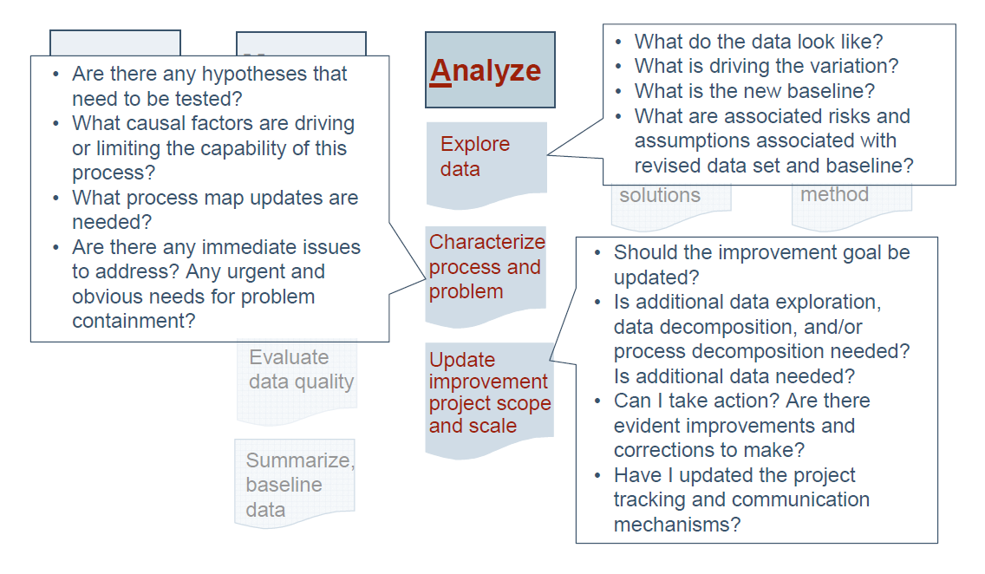
Figure 11: Guidance Questions to Ask in Analyze Phase

ANALYZE PHASE we determine and analyze the root cause of defects. The tools discussed in this phase are:
- Histogram
- Pareto Chart
- Run Chart
- Scatter Plot
- Regression Analysis
- Cause and Effect/Fishbone Diagram
- 5 Whys
- One of the most important steps in the DMAIC process – Analyze Phase is the root cause analysis. This is where the real cause of the problem is uncovered.
- Many problem-solving processes applied without the benefit of the Six Sigma methodology, result in managing a symptom of the problem rather than eliminating the root cause of the problem.
- Root cause is one that, if corrected, would prevent a recurrence of the problem. There may be a series of causes that are identified, one leading to another or more than one cause that combine to create the problem.

1. Histogram
- A histogram is used to graphically summarize and display the distribution of a process data set.
- It is a visual representation of variable data.
- It organizes data to describe process performance.
- It displays centering of the data and pattern of variation.
- It demonstrates the underlying distribution of the data. Histogram can be used to check whether the data is normally distributed or not.
- It provides valuable information for predicting future performance.
- It helps to identify whether the process is capable of meeting requirements.
- Creating Histogram – steps involved
- Collect the variable data in a table.
- Ensure that all the measurements are in the same unit
- Arrange the data in ascending order such that the minimum and maximum value can be identified
- Choose some suitable interval length of uniform size
- Use a check sheet to count the number of observations corresponding to each interval
- The number of observations for a particular interval is said to be the height of that interval and displayed as vertical bars.

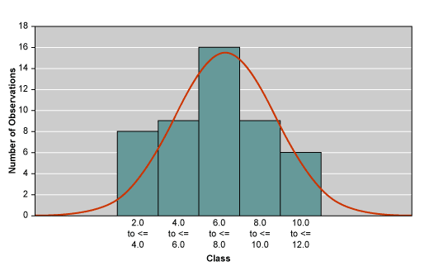Figure 12: Sample Histogram
- In this sample diagram raw data is displayed in the form of a histogram. Also note the shape of the underlying distribution

- Important aspects to be considered when studying Histogram:
- Location of mean of the process
- Spread (variation) of the process
- Shape (pattern) of the process

2. Pareto Chart
- The Pareto Diagram is named after Vilfredo Pareto, an economist from Italy. Pareto studied distribution of wealth and found that the distribution was not equal across the population. He found – majority of the wealth is concentrated in relatively few.
- Pareto’s theory was popularized by Dr. Joseph M. Juran, who is regarded as the father of quality control. It was Dr. Juran who called the 80-20 ratio propounded by Pareto as the “Pareto Principle”.
- Dr. Juran termed those few contributors which account for bulk of the effect as ‘Vital few’. He termed other sources which do not contribute significantly to the effect as ‘Trivial many’. It is a ranked comparison of factors related to a quality problem.
- Pareto diagram displays the relative importance of problems is a simple visual format. It’s a graphical tool for analyzing and ranking problem causes from most significant to least significant. It is a bar chart listing the identified causes of a problem in order of their frequency or importance to it.
- Since availability of money, time and other resources are restricted, Pareto analysis helps the team to consider only vital few problematic factors out of trivial many, which if addressed with due care, will bring greatest rewards with minimum resources.
- Pareto diagram is based on the Pareto Principle, also known as 80-20 rule, which states that a small number of causes (20%) is responsible for a large percentage (80%) of the effect.
- In a Six Sigma project, there are several available opportunities which can be followed to attain the project objectives. Pareto chart helps in identifying and ranking which of the opportunities would yield maximum benefits and hence should be pursued first
- Pareto Diagram – steps involved are
- Put together a cross functional team who have knowledge of the different opportunities or problems.
- Create different categories for the opportunities.
- Select a time interval for the analysis which is reasonable.
- Determine the total occurrences of events in each category.
- Rank the total occurrences in each category from maximum to minimum.
- Compute the percentage for each category by dividing by the category total and multiplying by 100.
- Create a graph of the opportunities – with the category names in the X Axis and the % of opportunities in the Y Axis.

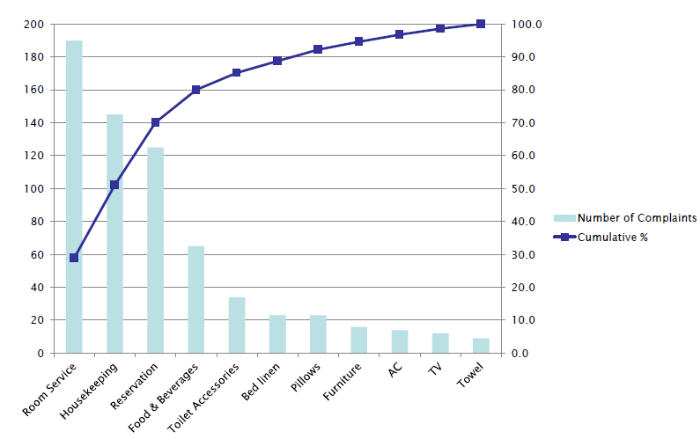
Figure 13: A Pareto on Complaints Received in a Hotel
- In the sample diagram the hotel is concerned about the increase in complaints.
- The horizontal axis represents various types of complaints and the vertical axis displays the number of complaints in each category.
- The right-hand vertical axis displays the cumulative percentage of the complaints. The blue curve represents this data.
- From this Pareto diagram, we can see that only the first four complaint category (Room service, Housekeeping, Reservation, Food and Beverages) constitute 80% share of the total complaints. Hence these four areas need immediate attention to improve the process performance.

3. Run Chart
- The run chart is a powerful, simple and easy-to-use process improvement tool. A run chart is used to determine whether or not the central tendency of a process is changing.
- It does not require tedious calculations or special software to produce. It plots observed values on the y-axis and the times they were observed on the x-axis. The terms time-series chart and run chart are used interchangeably.
- These are plots of data arranged in a time or order sequence is used for preliminary analysis of data measured on a continuous scale. (e.g. performance of a machine or person over time)
- Helps identify whether the system is under control – as defined by Shewhart (1931, 1980) “A phenomenon will be said to be controlled when, through the use of past experience, we can predict, at least within limits, how the phenomenon may be expected to vary in the future. Here it is understood that prediction within limits means that we can state, at least approximately, the probability that the observed phenomenon will fall within the given limits.”
- Helps identify common causes and special causes of variation

- Common cause: These are inherent in the process, can be predicted within reasonable limits and caused by natural variation in the process.

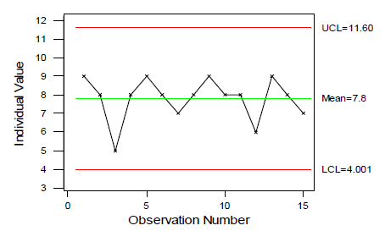
Figure 14: Example of Common Cause

- Special cause: These variations may be caused because of extraneous or unexpected reasons. Special cause of variations cannot be predicted and caused by unexpected variation in the process.

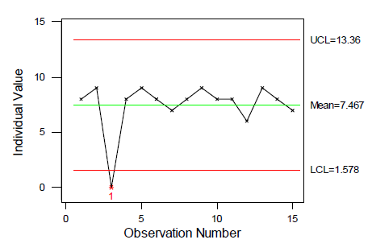
Figure 15: Example of Special Cause

- How is a run chart useful?
- It helps determine the special causes of variation.
- Determine if there are some values which are very much above or below the median (e.g. in this case, customer # 7 who takes 20 minutes to service is a special cause of variation) – we can analyze to find out what resulted in the special cause of variation e.g. did the customer not have all his documents, speak a different language etc?
- Determine Trends i.e. unusually long series of consecutive data points above or below the median. In the diagram, we do not have any trends. However, if we find a trend e.g. 7 data points where the customer service rep takes more than 10 minutes (median) to service a customer, this is a special cause of variation. We can try to figure out whether the customer service rep was tired, or the computer systems were not functioning properly etc.
- Helps determine the median value, and possibility of process improvements (e.g. if we could decrease the median time for servicing customers from 10 minutes to 8 minutes through improved processes or automation, it will mean savings for everybody).
- Helps determine the common cause of variation. (e.g. in this example, most customers are serviced between 10 + 3 minutes i.e. between 7 minutes and 13 minutes). Reduction of common cause of variation helps in further process improvement.
- How to Create a Run Chart?
There are seven steps to creating a run chart:
  - Decide on the measure to be analyzed (assuming there is a reliable measurement system in place).
  - Gather the data – have a minimum of 10 data points.
  - Draw a graph with a vertical line and a horizontal line.
  - On the vertical line, or the y-axis, draw the scale relative to the variable you are measuring.
  - On the horizontal line, or the x-axis, draw the time or sequence scale.
  - Calculate the mean/median (whichever the data set indicates to be appropriate) and draw a horizontal line at that value – going across the graph.
  - Plot the data in the sequence, or the time order, in which the data was collected.
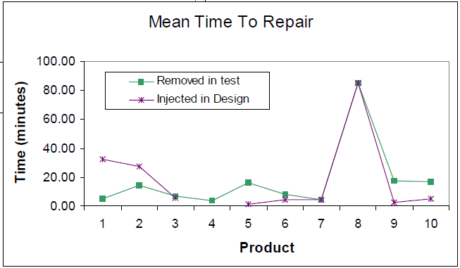
Figure 16: Example of Run Chart
4. Scatter Plot
- It is a graphical representation that depicts the possible relationship or association between two variables, factors or characteristics.
- It provides both a visual and statistical means to test the strength of a relationship.
- Construction of a Scatter Plot:
- Collect the data on both variables, preferable sample size of 20 or more.
- Plot the data points on a XY plane where variable 1 is plotted along X axis and variable 2 is plotted along Y axis.
- Identify the linear relationship between them if it exists.
- Identify the strength of the linear relationship as strong/ weak positive, and strong/ weak negative.

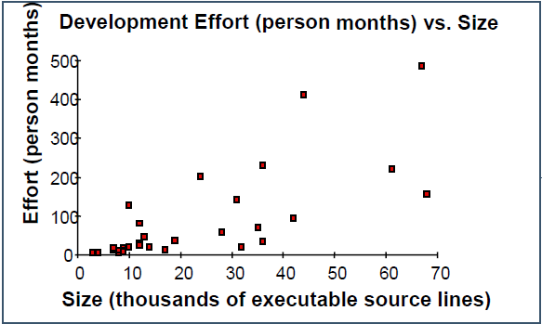
Figure 17: Example of Scatter Plot

5. Regression Analysis
- Regression is used to understand the relationship between two or more variables. Regression analysis makes it possible to predict one variable from the knowledge about the other. Regression analysis is a form of predictive modeling technique which investigates the relationship between a dependent (target) and independent variable (s) (predictor).
- Regression analysis is a widely used statistical technique; it helps investigate and model relationships between variables. It also uses a derived model to predict a variable of interest.
- Applying regression does require special attention. Each process step – from model specification and data collection, to model building and model validation, to interpreting the developed model – needs to be carefully examined and executed.
- The potential applications of regression analysis are numerous and can be found in almost every field, including economics, biology, management, chemical science and social science. This technique is also used for forecasting, time series modeling and finding the causal effect relationship between the variables. We can predict future sales of an organization based on current & past information. For example, relationship between rash driving and number of road accidents by a driver is best studied through regression.
- Regression analysis is an important tool for modeling and analyzing data. Here, we fit a curve / line to the data points, in such a manner that the differences between the distances of data points from the curve or line is minimized.
- There are multiple benefits of using regression analysis. They are as follows:
- It indicates the significant relationships between dependent variable and independent variable.
- It indicates the strength of impact of multiple independent variables on a dependent variable.
- Regression analysis also allows us to compare the effects of variables measured on different scales, such as the effect of price changes and the number of promotional activities.
- These benefits help market researchers / data analysts / data scientists to eliminate and evaluate the best set of variables to be used for building predictive models.
- There are various kinds of regression techniques available to make predictions. These techniques are mostly driven by three metrics (number of independent variables, shape of regression line and type of dependent variables).

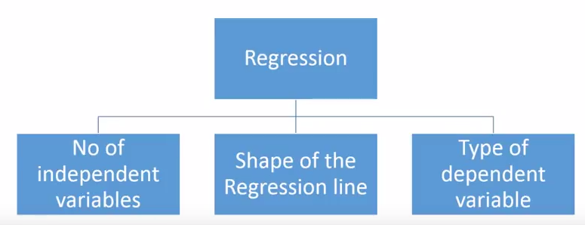
Figure 18: Types of Regression

- Regression Analysis assumes that one variable is dependent upon: A) another single independent variable (Simple Regression), or B) multiple independent variables (Multiple Regression).
- Regression plots a line of best fit to the data using the least-squares method. Linear Regression establishes a relationship between dependent variable (Y) and one or more independent variables (X) using a best fit straight line (also known as regression line). You can see an example below of linear regression using (as an example) a car door scatter plot:
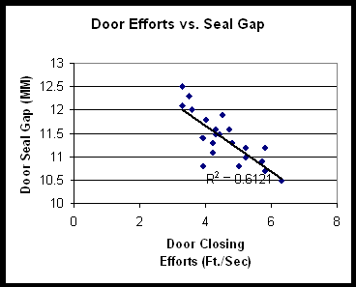
Figure 19: Example of Linear Regression
Notice the line has a downward slope, i.e., a strong negative correlation is expressed.
- Multiple Regression Analysis uses a similar methodology as Simple Regression, but includes more than one independent variable. Econometric models are a good example, where the dependent variable of GNP may be analyzed in terms of multiple independent variables, such as interest rates, productivity growth, government spending, savings rates, consumer confidence, etc.
- Many times historical data is used in multiple regressions in an attempt to identify the most significant inputs to a process. The benefit of this type of analysis is that it can be done very quickly and relatively simply.

6. Cause and Effect/Fishbone Diagram
- A popular means for identifying the causes of a particular problem, or effect, is the aptly named cause-and-effect diagram. As the completed graphic resembles the bones of a fish, it is also commonly referred to as a “fishbone”.
- The fishbone diagram was developed by Kaoru Ishikawa, who pioneered quality management processes in the Kawasaki shipyards in Japan. The fishbone diagram is used to explore all the potential or real causes (Xs) that result in a single effect (Y). Hence this is also called Ishikawa diagram.
- The head of the “fish” is the problem statement, such as “late delivery of product”. From the head is drawn a straight horizontal line, and all of the “bones” coming off that line represent categories of possible causes.
- The most common cause categories used are the so called 6Ms (method, machine, man, mother nature, material and measurements) and the 5Ps (policies, plans, procedures, people and plant). It also is common to use the high-level process steps from a SIPOC (suppliers, inputs, process, output and customers) map as cause categories.
- The most important thing when creating a fishbone diagram is to ask “why” five times to get from the effects to the potential root causes.
- Teams that start brainstorming within defined categories may find that as they dig further into a cause, the sub- or root cause might better fit into a different category (e.g., out-of-spec material that causes jams more appropriately fits in the Material category, rather than Machine).The categories are generally used to help spur ideas and should not constrain a team with unnecessary boundaries.
- While the cause-and-effect diagram has the benefit of being a visual tool that utilizes the input of many team members, its drawback is that it is based on perception and does not constitute a quantitative analysis. For that reason, it is best suited for projects in which hard data is unavailable, or as preliminary work to identify potential causes worthy of data collection and further analysis.
- After the diagramming is complete, the improvement team can tackle the root causes – either by immediately addressing the identified cause, or by using the information as input for additional analysis as needed.
- Benefits of Ishikawa diagram:
- Usually created by a group of people who have knowledge of the process and understand the problems in the present system.
- Is a very powerful tool to organize and graphically display all the knowledge the team has about a particular problem
- Clarifies the understanding the team has regarding the process. If an Ishikawa diagram does not show appropriate level of detail, it indicates that the team has a superficial knowledge of the problem. Hence, additional study of the system or involvement of Subject Matter Experts is required.
- Is a starting point to determine the Vital X’s that impact the customer’s critical to quality variable : Y.
- Steps involved in creation of Ishikawa diagram:
- 1.Create a process map of the existing system (Process Maps discussed earlier)
- 2. Define the problem to be solved. This could be a critical requirement or Y variable.
- 3.Put a team together who have good knowledge of the process and understand the problems involved with the process
- 4. Conduct a brainstorming or Nominal Group Technique session wherein determine all the causes of the problem.
- 5. Categorize the causes identified into groups and subgroups. A popular way to do this is through using Affinity diagrams. Once groups and subgroups are available, create an Ishikawa diagram using 3 steps:
a. Draw a box on the far right side where the problem under consideration is written down.
b. Draw a horizontal arrow which points to the box on the right
c. Write the names of categories above and below the horizontal line.
d. Start with high level groups and expand each group (upto 3 or 4 levels).
e. Write down the detailed cause data for each category.

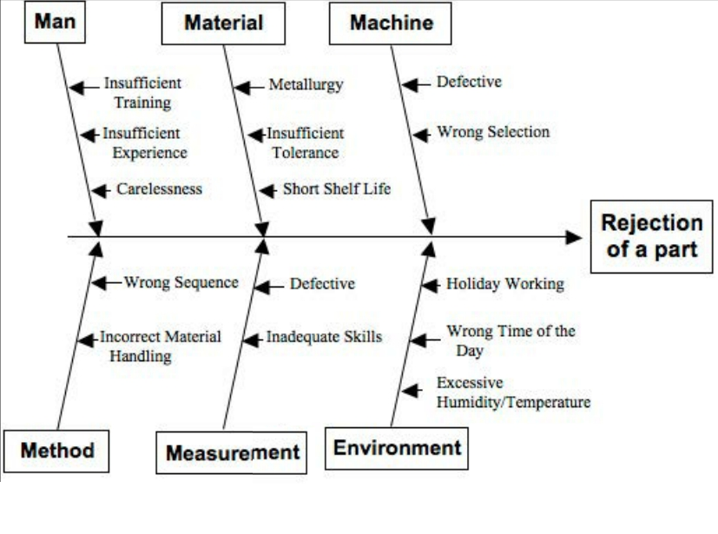Figure 20: Sample of Fish Bone Diagram

7. 5 Whys
- The 5 Whys is a technique used in the Analyze phase of the Six Sigma DMAIC methodology. The 5 Whys is a great Six Sigma tool that can be completed without a data collection plan.
- By repeatedly asking the question “Why” (five is a good rule of thumb), you can peel away the layers of symptoms which can lead to the root cause of a problem.
- Very often the ostensible reason for a problem will lead you to another question. Although this technique is called “5 Whys,” you may find that you will need to ask the question fewer or more times than five before you find the issue related to a problem.
- Benefits of the 5 Whys:
- Help identify the root cause of a problem.
- Determine the relationship between different root causes of a problem.
- One of the simplest tools; easy to complete without statistical analysis.
- When Is 5 Whys Most Useful?
- When problems involve human factors or interactions.
- In day-to-day business life; can be used within or without a Six Sigma project.
- How to Complete the 5 Whys
- Step1. Write down the specific problem. Writing the issue helps you formalize the problem and describe it completely. It also helps a team focus on the same problem.
- Step2. Ask Why the problem happens and write the answer down below the problem.
- Step3. If the answer you just provided doesn’t identify the root cause of the problem that you wrote down in Step 1, ask Why again and write that answer down.
- Step4. Loop back to step 3 until the team is in agreement that the problem’s root cause is identified. Again, this may take fewer or more times than five Whys.
- 5 Whys Example -
- Problem Statement: You are on your way home from work and your car stops in the middle of the road.
- 1. Why did your car stop?
– Because it ran out of gas.
- 2. Why did it run out of gas?
– Because I didn’t buy any gas on my way to work.
- 3. Why didn’t you buy any gas this morning?
– Because I didn’t have any money.
- 4. Why didn’t you have any money?
– Because I lost it all last night in a poker game.
- 5. Why did you lose your money in last night’s poker game?
– Because I’m not very good at “bluffing” when I don’t have a good hand.
- As you can see, in the above example the final Why leads the team to a statement (root cause) that the team can take action upon. It is much quicker to come up with a system to teach a person to “bluff” a hand than it is to try to directly solve the stated problems above without further investigation.

After completing visiting the tools in the Analyze phase we now move on to review, analyze and interpret tools in the Improve Phase.

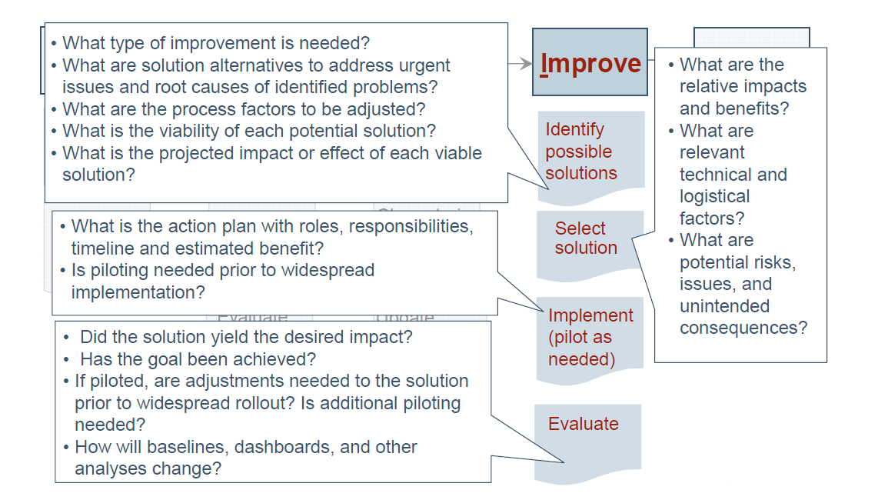 Figure 21: Guidance Questions to ask in Improve Phase
IMPROVE PHASE we improve the process by eliminating defects. The tools in this phase are:
- Brainstorming
- Mistake Proofing
- Design of Experiments
- Pugh Matrix
- QFD/House of Quality
- Failure Modes and Effects Analysis (FMEA)
- Simulation Software

1. Brainstorming
- A brainstorming session is a tool for generating as many ideas or solutions as possible to a problem or issue. It is not a tool for determining the best solution to a problem or issue.
- Before beginning any effective brainstorming session, ground rules must be set. The best way to have meaningful ground rules is to have the team create their own. This also allows the team to take ownership of acceptable and unacceptable behaviors. Only if the team hasn’t addressed the key ground rules should you (as the facilitator) add to the list.
- Once the ground rules list is generated gain consensus that the session will be conducted according to them, and post them in a highly visible location in the room.
- Here are four key ground rules that are useful when conducting a brainstorming session:
  - There are no dumb ideas. It is a brainstorming session, not a serious matter that requires only serious solutions. Remember, this is one of the more fun tools of quality, so keep the entire team involved!
  - Don’t criticize other people’s ideas. This is not a debate, discussion or forum for one person to display superiority over another.
  - Build on other people’s ideas. Often an idea suggested by one person can trigger a bigger and/or better idea by another person. Or a variation of an idea on the board could be the next “velcro” idea. It is this building of ideas that leads to out of the box thinking and fantastic ideas.
  - Reverse the thought of “quality over quantity.” Here we want quantity; the more creative ideas the better. As a facilitator, you can even make it a challenge to come up with as many ideas as possible and compare this team’s performance to the last brainstorming session you conducted.
- Brainstorming is a popular method of group interaction in both educational and business settings. In Six Sigma, brainstorming is usually most valuable when using tools such as failure mode and effects analysis.
- Fundamentals of Brainstorming
There are several fundamental requirements for a successful session:
- Everyone must be familiar with the problem.
- The problem must not be too complex or multifaceted. If it is, a smaller sub problem should be considered.
- A group of between three and 10 people is optimal. A smaller number does not give enough interaction between people so that ideas can feed off of one another. A larger group, on the other hand, is too cumbersome. Some people will be left out of the discussion and will become negative or apathetic – a fatal flaw to a brainstorming session.
- Preparing for a Session
- One of the most important things to do before a brainstorming session is to define the problem. The problem must be clear, not too big and captured in a definite question, such as “What service for mobile phones is not available now, but needed?”
- If the problem is too big, the chairperson should divide it into smaller components, each with its own question.
- Select Participants
The chairperson composes the brainstorming panel. Many variations are possible, but the following composition is suggested:
- Several core members of the project who have proven themselves
- Several guests from outside the project, but with affinity to the problem
- One idea collector who records the suggested ideas
- Draft a Background Memo
- The background memo is the invitation and informational letter for the participants, containing the session name, problem, time, date and place. The problem is described in the form of a question, and some example ideas are given.
- The ideas are solutions to the problem, used when the session slows down or goes off track. The memo should be sent to the participants at least two days in advance so that they can think about the problem beforehand.
- Create a List of Lead Questions
- The chairperson should stimulate creativity by suggesting a lead question to answer, such as “Can we combine these ideas?” or “How about a look from another perspective?” It is advised to prepare a list of such leads before the session begins.
- Three Simple Brainstorming Warm-ups
Brainstorming warm-ups are useful for getting people into the right frame of mind for a session. These three common warm-ups help those involved in the brainstorming process to overcome stumbling blocks and maximize creative results.
- Word
- Practice run
- Game of opposites
- Setting Session Rules
While participating in a brainstorming session, there are several rules that need to be followed to make it productive:
- No criticisms or negative judgments are allowed.
- Arrange for a relaxed atmosphere.
- Think quantity, not quality.
- Add to or expand the ideas of others.
- Variations on Classic Brainstorming
Newer variations of brainstorming seek to overcome barriers such as production blocking and may well prove superior to the original technique. The following are some of the alternative options:
- Nominal Group Technique
- Group Passing Technique
- Team Idea Mapping
- Electronic Brainstorming
- Individual Brainstorming
- The Power of Brainstorming
- It allows a team to obtain the best possible results by combining all resources available.
- It helps practitioners sort out ideas so they can plan ahead while gathering new data, and can accelerate the information-gathering session because each person in the session adds value to the end result.
- No idea is unwanted, and all input is welcomed, which can lead to many valuable contributions.

2. Mistake Proofing (Poka Yoke)
- Japanese equivalent Poka-Yoke (pronounced PO-ka yo-KAY), is the use of any automatic device or method that either makes it impossible for an error to occur or makes the error immediately obvious once it has occurred. i.e. is either to make errors impossible or immediately detectable
- When to Use Mistake Proofing
- When a process step has been identified where human error can cause mistakes or defects to occur, especially in processes that rely on the worker’s attention, skill or experience.
- In a service process, where the customer can make an error which affects the output.
- At a hand-off step in a process, when output or (for service processes) the customer is transferred to another worker.
- When a minor error early in the process causes major problems later in the process.
- When the consequences of an error are expensive or dangerous.
Prevention
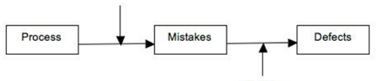
Poka-yoke that focuses here, works on prevention or on making mistakes impossible
Detection
Poka-yoke that focuses here, works on mistake,
detection or on making sure mistakes do not turn into defects

Figure 22: Prevention & Detection in Poka Yoke

- Mistake–Proofing Procedure
- Obtain or create a flowchart of the process. Review each step, thinking about where and when human errors are likely to occur.
- For each potential error, work back through the process to find its source.
- For each error, think of potential ways to make it impossible for the error to occur. Consider:
    - Elimination—eliminating the step that causes the error.
    - Replacement—replacing the step with an error-proof one.
    - Facilitation—making the correct action far easier than the error.
- If you cannot make it impossible for the error to occur, think of ways to detect the error and minimize its effects. Consider inspection method, setting function and regulatory function.
- Choose the best mistake-proofing method or device for each error. Test it, and then implement it.
Three kinds of inspection methods provide rapid feedback:
  - Successive inspection is done at the next step of the process by the next worker.
  - Self-inspection means workers check their own work immediately after doing it.
  - Source inspection checks, before the process step takes place, that conditions are correct. Often it’s automatic and keeps the process from proceeding until conditions are right.
Setting functions are the methods by which a process parameter or product attribute is inspected for errors:
- The contact or physical method checks a physical characteristic such as diameter or temperature, often using a sensor.
- The motion-step or sequencing method checks the process sequence to make sure steps are done in order.
- The fixed-value or grouping and counting method counts repetitions or parts or weighs an item to ensure completeness.
- A fourth setting function is sometimes added: information enhancement. This makes sure information is available and perceivable when and where required.
- Regulatory functions are signals that alert the workers that an error has occurred:
- Warning functions are bells, buzzers, lights and other sensory signals. Consider using color-coding, shapes, symbols and distinctive sounds.
- Control functions prevent the process from proceeding until the error is corrected (if the error has already taken place) or conditions are correct (if the inspection was a source inspection and the error has not yet occurred).

3. Design of Experiments
- Design of Experiments (DOE) was first conceived and developed by Sir Ronald A. Fisher in the 1920s and 1930s. Fisher was a brilliant mathematician and geneticist working to improve crop yields in England.
- Design of Experiments is a very powerful statistical tool to determine cause and effect relationships to determine the most optimal solution.
- It’s a systematic method to determine the relationship between factors affecting a process and the output of that process. In other words, it is used to find cause-and-effect relationships. This information is needed to manage process inputs in order to optimize the output.
- It is a technique to optimize any process or product better, faster and cheaper than other optimization methods, including A/B testing (also known as OFAT or one-factor-at-a-time) and “expert” guessing.
- DOE is the best data collection strategy that is out there today when our goal is to investigate relationships between inputs and outputs of a process. DOE allows you to optimize an output variable based on a bunch of different input factors.
- It is important for practitioners to understand basic DOE concepts for proper application.
- Every process can be considered to be a black-box with some inputs and some outputs. Using Design of Experiments processes or settings are changed in a systematic way so that the optimal solution can be found.
- Consider an example where the project team would like to decrease cycle time (Y). This is possible by a combination of following 4 input factors (X):
- Getting better equipment
- Improving worker training
- JIT processes
- Better vendor management.
- However, there is a cost associated with making changes to the factors mentioned. Using Design of Experiments, the team would be able to determine the most appropriate combination of input factors (X) which would maximize the cycle time (Y)
- Benefits of Design of Experiments include:
- Better Quality
- Lower Cycle time
- Reduction of defects
- Reduction of process variability
- Cost of poor Quality (COPQ) decreases
- Return on Investment (ROI) increases
- Increase in customer satisfaction
- Improvement in customer satisfaction
- Learning more about the process
- Design of Experiments: Important terms and concepts
- Factor: Any variable that may influence a process.
- Levels: Setting or category that a variable may take. Two or more levels could be chosen for each category
- Trial: One run during the experiment. Factors are set at different levels for each trial
- Response Variable: Specific parameter used to decide if the process is improving; helps in determining the type of data to be collected
- Interaction between factors: When an experiment is being run, two or more factors may interact and influence the response variable. It is important to understand the interaction between factors while doing Design of Experiments study
- One-factor-at-a-time: Level of the first factor is changed while others stay the same. One or more trials are run until the best level of first factor is determined which maximizes the response variable. These are the simplest experiments used in DOE.
- Factorial Design: Allows experimentation on many factors simultaneously. Some examples:
- Two-factorial design: Two factors are changed simultaneously and the impact on the response variable is studied.
- Fractional factorial experiment: Only some of the possible factors and levels are studied simultaneously
- Full factorial experiment: All the combinations of factors and levels are studied simultaneously.
- Controllable input factors, or x factors, are those input parameters that can be modified in an experiment or process. The controllable input factors can be modified to optimize the output.

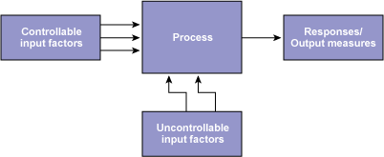
Figure 23: Process Factors and Responses

- Uncontrollable input factors are those parameters that cannot be changed. These factors need to be recognized to understand how they may affect the response.
- Responses, or output measures, are the elements of the process outcome that gage the desired effect.
- Hypothesis testing helps determine the significant factors using statistical methods. There are two possibilities in a hypothesis statement: the null and the alternative. The null hypothesis is valid if the status quo is true. The alternative hypothesis is true if the status quo is not valid. Testing is done at a level of significance, which is based on a probability.
- Blocking: is an experimental technique to avoid any unwanted variations in the input or experimental process. For example, an experiment may be conducted with the same equipment to avoid any equipment variations.
- Replication” Practitioners perform the same combination run more than once, in order to get an estimate for the amount of random error that could be part of the process.
- Interaction: When an experiment has three or more variables, an interaction is a situation in which the simultaneous influence of two variables on a third is not added.
- The objective of a design of experiments is to optimize the value of a response variable by changing the values, referred to as levels, of the factors that affect the response. Although often a response is continuous in nature, there are some cases in which the response falls in the attribute category (e.g., pass/fail, accept/reject, etc.).
- DOE helps in the following ways:
- Identifying the vital few sources of variation.
- Quantify the effects of the important Xs including their interactions.
- Performing DOE produces an equation that quantifies the relationship between the process Xs and the process output Y, thus enabling the transition to the Y=f(x) philosophy of Six Sigma

4. Pugh Matrix
- The Pugh matrix was developed by, and named after, design engineer Stuart Pugh. A criteria-based matrix, it is used to help a team quantitatively determine from several alternatives the “best” solutions for a given problem.
- Commonly used for product design, it can be applied to virtually any decision making. A Pugh matrix will help rank potential solutions against the voice of the customer (VOC).
- Often used in a team setting, a Pugh matrix facilitates the evaluation of various solutions with respect to defined selection criteria – requirements or desired characteristics of the solution, generally as defined with voice-of-the-customer input.
- The Pugh matrix helps determine which items or potential solutions are more important or ‘better’ than others. It is employed after capturing voice of the customer (VOC).
- It is a scoring matrix used for concept selection in which options are assigned scores relative to criteria. The selection is made based on the consolidated scores. Before starting a detailed design, there are many options – this tool helps with selecting the best option. This tool is also known as a criteria-based matrix.
- The Pugh matrix is a tool used to facilitate a disciplined, team-based process for concept generation and selection. Several concepts are evaluated according to their strengths and weaknesses against a reference concept called the datum (base concept). The datum is the best current concept available at each iteration of the matrix.
- The Pugh matrix allows an individual or team to:
- Compare different concepts
- Create strong alternative concepts from weaker concepts
- Arrive at an optimal concept that may be a hybrid or variant of the best of other concepts
- This matrix encourages comparison of several different concepts against a base concept, creating stronger concepts and eliminating weaker ones until an optimal concept finally is reached.
- Also, the Pugh matrix is useful because it does not require a great amount of quantitative data on design concepts, which generally is not available at this point in the process anyway.
- Consider a family that wants to buy a new car. A simple Pugh matrix analysis of their choices would look like the following.
 | Solutions
Selection Criteria | Baseline –  Current Car | Car A | Car B | Car C
Fuel system | 0 | -2 | 2 | -1
Four-door | 0 | 2 | 2 | -2
Miles per gallon | 0 | 2 | 2 | 0
Sound system | 0 | 1 | 2 | -1
Warranty plan | 0 | 0 | 2 | -1
Table 6: Example of Pugh Matrix
- The family’s current car is the baseline for this decision and is marked with all zeros. Each of the alternative car options are evaluated against the criteria in the far left column on a range from -2 to 2, with -2 being a poor match to a given criterion and +2 being the best match to a criterion. Car B, with all best match marks, is the best solution based on the specified criteria.

5. Quality Function Deployment (QFD)/House of Quality
- Shigeru Mizuno and Yoji Akao created QFD in Japan in the 1960s. It was first presented to an American audience in 1983 when ‘Quality Progress’ published the article “Quality Function Deployment and CWQC in Japan” by Masao Kogure and Akao. Shortly thereafter, the Kaizen Institute (then Cambridge Research) invited Akao to Chicago to lecture on QFD.
- Quality Function Deployment (QFD), often referred to as listening to the voice of the customer, is a structured method for translating customer requirements into appropriate technical requirements for each stage of product development and production.
- QFD offers a customer-oriented approach, supporting design teams in developing new products based on an assessment of customer needs. Customer needs are translated into design attributes, which are then deployed in process and quality requirements.
- It is a way to develop a design, aimed at satisfying the consumer and translate the consumer’s demands into design targets and major quality assurance points to be used throughout the production stage.
- QFD is different because it looks for customer requirements and maximizes positive quality that creates value. (Is the product fun and easy to use?) QFD can be used in product development, business, site and test planning, and problem solving. It is used in the aerospace, manufacturing, software and IT, defense, government, healthcare and service industries.
- Benefits derived from using the QFD tool include:
- The creation of work teams that include multiple skills and experiences
- The determination of specific work aims
- A display of a wide variety of important design information in one place in a compact form
- Reduced overall costs from realizing a reduction in design changes
- Reduced production costs by eliminating redundant features and over-design• Improve a company’s processes, products or services.
- Produce a faster outcome than other methods can.
- Give definition to the design process.
- Help a team stay focused.
- Allow for easy management and peer review of design activities.
- Help present the information graphically.
- Leave the team well positioned in
- QFD is composed of four stages:
- Complete the house of quality (HOQ).
- Design the product – Determine tolerance of each part of the product so that it satisfies the target value identified from the HOQ.
- Design the process – Determine the necessary production process that will satisfy tolerances established during product design.
- Control the process – Determine quality standards for the new product design.
- The QFD Matrix
A typical QFD matrix has two parts (refer Figure 24):
- The horizontal part contains customer information. It lists the customer’s needs and wants and determines their relative importance. It also lists customer feedback and complaints.
- The vertical part contains technical information that responds to customer input. It translates customer needs and wants into language that can be measured, examines the relationship between customer and technical requirements, and contains competitive technical data, the targets or goals set by a company to achieve competitiveness.
- The target value—the level of performance that needs to be achieved to meet the perceived outcome of an organization’s QFD project—is determined by comparing the customers’ evaluations to the competitive technical assessments.
- The co-relationships of the technical requirements are then examined. The objective is to locate any requirements that conflict with each other. Other sections can be added to the matrix depending on a company’s needs and the services it provides.

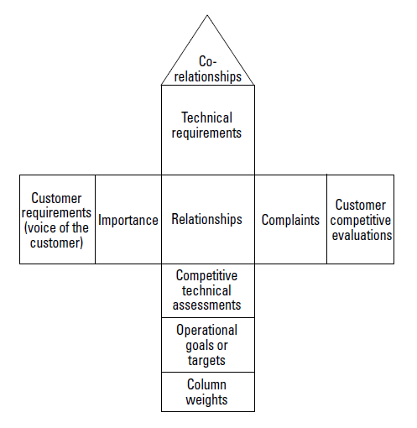
Figure 24: The Basic Quality Function Deployment Matrix

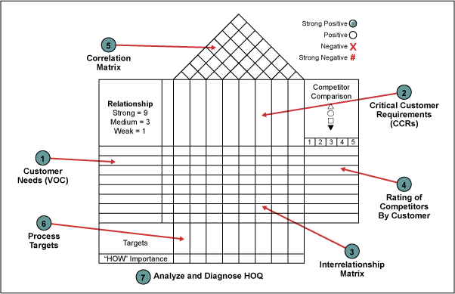
Figure 25: Details of House of Quality

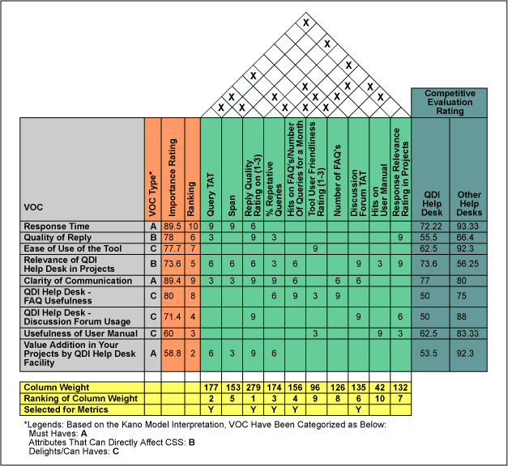
Figure 26: Sample Quality Function Deployment

- QFD, in addition to helping to reduce defects, provides organizations with a tool to maximize positive quality such as ease of use or luxury. Positive quality offered is linked to achieving the customer delight factor.
- Repeating the QFD exercise regularly allows organizations to continually address the changing needs of customers.

6. Failure Modes and Effects Analysis (FMEA)

- Failure Modes and Effects Analysis (FMEA) evolved at the National Aeronautics and Space Administration, an environment where the interest in preventing failures is extremely high.
- FMEA was later popularized by the automobile industry and in recent years has become more widespread among Six Sigma practitioners. It is routinely used even in transactional functions.
- FMEA is a risk assessment tool. Through the structured approach of an FMEA, improvement teams identify possible ways in which a product or process can fail, specify the subsequent effects, quantify the severity of those potential failures, and assess the likelihood of their occurrence.
- FMEA can be used to rank and prioritize the possible causes of failures as well as develop and implement preventative actions, with responsible persons assigned to carry out these actions. While the name of FMEA concentrates on how a process fails, the real objective is to concentrate on assessing the effects and process controls for the root causes related to any given failure mode.
- The failure mode and effects analysis FMEA tool has several variations. In transactional environments, it is sometimes referred to as an EMEA – where E stands for human errors. Other variations include the process FMEA (pFMEA) and design FMEA (dFMEA). The fundamental purpose of any FMEA, however, is to identify, evaluate and take actions to reduce risk of failure.
- Just as there are many variations of the FMEA, there are also many uses for the tool within Six Sigma projects. Although it’s typically taught in the Improve stage of training, it has a place in other phases as well. But before practitioners can gain varied benefits from the tool, they must first be clear on how to use it.
- FEMA helps evaluate the risk associated with steps in a process or with the steps in the implementation plan of any project. Potential failure modes and their potential resulting effects are identified and scored for severity of impact to the organization. Potential causes are then identified and scored based on frequency or likelihood of occurrence. Finally, present controls are identified and scored based on the organization’s ability to prevent, mitigate or detect these failure modes. The three scores are then multiplied together to create a risk priority number (RPN).
- Before proceeding with how to use an FMEA within the different phases of a Six Sigma project, it is best to review some key FMEA terms:
- Failure mode – The way in which a process can fail
- Effect – The impact on the process or customer requirements as a result of the failure
- Severity – The impact of the effect on the customer or process
- Root cause – The initiating source of the failure mode
- Occurrence (or frequency) – How often the failure is likely to occur
- Detection – The likelihood that the failure will be discovered in a timely manner or before it can reach the customer.
- Risk priority number (RPN) – The value computed by multiplying the values assigned to Severity, Occurrence and Detection
- While the overall approach of the FMEA does not change depending upon the DMAIC phase, the focus of its use does change.
- In Measure, the FMEA can be used as a prioritization tool to understand and fine tune the focus of a Lean Six Sigma project. In addition, it also can be used to determine what can go wrong with the process, and what data the team should collect as part of its process metrics.
- In Analyze, the FMEA helps to address where to look for root causes. It should be noted, however, that an FMEA is not a tool to identify root cases; but, frequently practitioners can document root causes in an FMEA.
- In Improve, the FMEA i used to test a solution or process improvement. This testing can make the solution or process more robust, and help identify corrective, preventive and mitigate actions should failures or errors crop up later.
- In the Measure, Analyze and Improve phases, an FMEA is typically the result of brainstorming because quantitative data is usually not available. However, in Control, an FMEA is updated based on real data and is helpful for continuous and ongoing improvement.
- Here are some potential targets for a FMEA application:
- New processes being designed
- Existing processes being changed
- Carry-over processes for use in new applications or new environments
- After completing a problem-solving study (to prevent recurrence)
- When preliminary understanding of the processes is available (for a process FMEA)
- After system functions are defined, but before specific hardware is selected (for a system FMEA)
- After product functions are defined, but before the design is approved and released to manufacturing (for a design FMEA)
- Preparing and Updating the FMEA
- The responsible process owner leads the FMEA team.
- The team approach to preparing FMEA is recommended.
- The responsible process owner is expected to involve multi-disciplinary representatives from all affected activities. Team members should include subject matter experts and advisors as appropriate.
- Each process owner is responsible for keeping the FMEA updated.
- Benefits of FMEA
Here are the benefits of FMEA:
- Captures the collective knowledge of a team
- Improves the quality, reliability, and safety of the process
- Logical, structured process for identifying process areas of concern
- Reduces process development time, cost
- Documents and tracks risk reduction activities
- Helps to identify critical-to-quality characteristics
- Provides historical records; establishes baseline
- Helps increase customer satisfaction and safety
- FMEA you can achieve:
- Better quality and clinical outcomes
- Safer environment for patients, families and employees
- Greater efficiency and reduced costs
- Stronger leadership capabilities
- Increased revenue and market share
- Optimized technology and workflow
- Combining Six Sigma, change management and FMEA you can achieve:
- Better quality and clinical outcomes
- Safer environment for patients, families and employees
- Greater efficiency and reduced costs
- Stronger leadership capabilities
- Increased revenue and market share
- Optimized technology and workflow
- While FMEA concentrates on how a process fails, the real objective is to concentrate on assessing the effects and process controls for the root causes related to any given failure mode. Practitioners examine the root cause-failure-effect sequence by starting in the middle and working outward. During this evaluation, they not only discover root causes and prioritize them for action to eliminate risk, but they also come away with a valuable documentation of how the particular process works.

7. Simulation Software

- To test changes to processes and product designs without using valuable real-life resources, many Six Sigma practitioners turn to simulation software. This software allows them to create models based on a process or, in some cases, apply models from a built-in template library to run various experiments and do analyses. Finally, simulation software can help make data-based decisions.
- Simulation is imitation of the operations of a real world process or system over time. It involves the generation of artificial history of the system and the observation of that artificial history to draw inferences concerning the operating characteristics of the real system.
- Operations research and simulation modeling have been used in the past by upper management for decision-making in various areas, including supply chain management, manufacturing applications, semiconductor manufacturing, construction engineering and military applications.
- Simulation is in use in service industries to model and analyze call flows, human resource management and forecasting. Usage had generally been a one-time effort due to various disadvantages of the simulation concept, but current technology and development have actually converted these disadvantages into advantages. Some of the important ones are:
- Data Availability – Simulation requires a large amount of data. In the past, data was generally not available and had to be collected, which was a strenuous activity and took a lot of time. Now the use of enterprise resource planning software and customer relationship management programs provide large volumes of data. That data can be used as input for simulation.
- Cost of Modeling – In the past, companies developed their own simulation software to supplement their analysis. That software was costly to procure. Now, many off-the-shelf simulation software products have been developed. They are cheaper and easy to use, and can be applied in different business scenarios. The software packages also provide graphical representations of the model.
- Extensive Knowledge of Probability and Statistics – Simulation modeling requires the use of probability and statistics to model the system. This was a hindrance in the past as many system modelers were reluctant to bury themselves with probability and statistics. The current simulation software packages have input analyzers – this also is available with many quality software tools – which help with the data conversions. Only a working knowledge of statistics is a prerequisite to effective simulation modeling.
- Time to Run Simulation – Thanks to the current computer processor speeds, simulation can be run quickly or even be slowed down to assist the project team
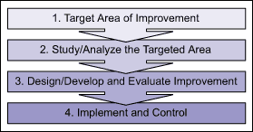 Figure 27: Quality Improvement Framework

- Simulation modeling and analysis as a tool can be best used in Steps 2 and 3 in the framework above. It is most useful when studying the system, designing the system, evaluating alternatives and backing up the results of the improved process.
- A typical example of how it can be done is shown in Figure 2 for a Six Sigma DMAIC (Define, Measure, Analyze, Improve, Control) process. DMAIC applies to an existing process that needs improvement. It is best applicable to continuous defect reduction in a cross functional or one-functional environment.
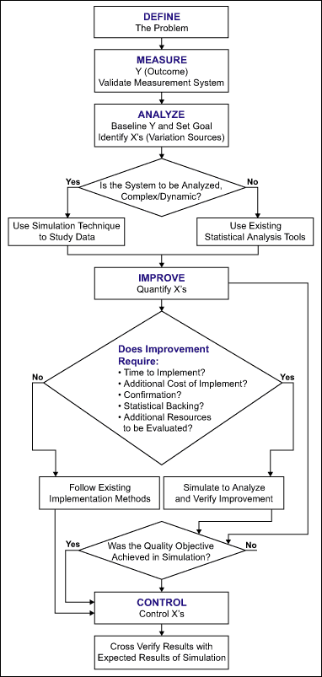 Figure 28: DMAIC with Simulation Tool
- Enhancing Current Methods
Simulation modeling and analysis can be used in a quality improvement framework as an enhancement to current methods. Some key points to remember when deciding to use simulation are:
- GIGO (garbage in, garbage out) applies to simulation. The way the system is modeled and data is entered will determine the efficiency of the model itself. This will mean that the project team or at least an analyst must be trained in the use of simulation. The analyst or team must know the system well enough to gauge the factors and level of detail to be simulated.
- Simulation must not be performed if the team does not have time or resources for a detailed quality project. This would obviously mean a sub-optimal solution or a stopgap solution.
- Many off-the-shelf simulation software is available in the market. A detailed feature study needs to be made before purchase so the software will best fit the organization’s needs.
- The simulation software is still a cost to the company. The monetary gains will be seen only after successful completion of the project.
- Simulation modeling as a tool currently is the best for a continuous improvement process. Organizations have a lot of new challenges when it comes to quality of service. These new challenges can only be dealt with by taking it up with newer ways of finding solutions. The quality framework needs to be upgraded as the situation demands.

After completing visiting the tools in the Improve phase we now move on to review, analyze and interpret tools in the Control Phase.

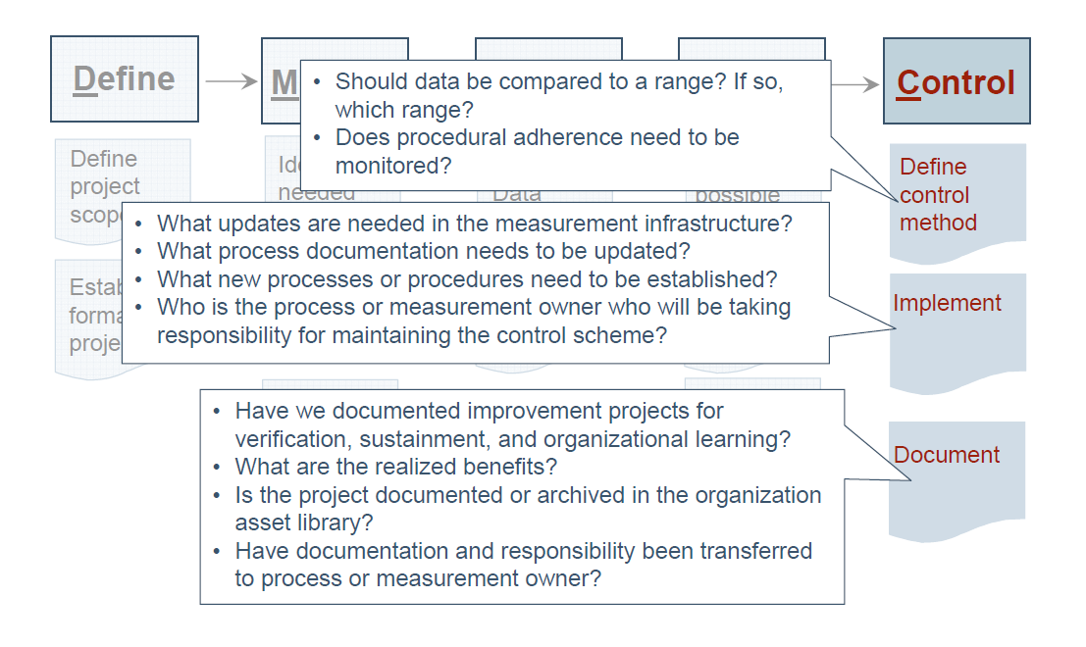
Figure 29: Guidance Questions to ask in Control Phase

Control PHASE we control future process performance. The tools discussed in this phase are:
- Process Sigma Calculation
- Control Charts (Variable and Attribute)
- Cost Savings Calculations
- Control Plan

1. Process Sigma Calculation
- We have seen the definitions required earlier, the five-step process to calculate process sigma is:
- Step 1: Define Your Opportunities
    - An opportunity is the lowest defect noticeable by a customer. Typically, most products (and services) have more than one opportunity of going wrong. For example, it is estimated than in electronics assembly a diode could have the following opportunities for error: 1) wrong diode and 2) wrong polarity (inserted backwards), so for each assembly shipped, at least two defect opportunities could be assigned for each diode.
    - An opportunity was defined as a minute of uptime. That was the lowest (shortest) time period that was noticeable by a customer.
- Step 2: Define Your Defects
    - Defining what a defect is to your customer is not easy. You need to first communicate with your customer through focus groups, surveys, or other voice of the customer tools. For example: To Motorola pager customers, a defect was defined as a pager that did not function properly.
    - A defect is defined by the customer as one instance of failure. An additional defect would be noticed for every instance that elapsed where the customer didn’t have the product (and service) available.
- Step 3: Measure Your Opportunities and Defects
    - Now that you have clear definitions of what an opportunity and defect are, you can measure them. The power company example is relatively straight forward, but sometimes you may need to set up a formal data collection plan and organize the process of data collection.
- Step 4: Calculate Your Yield
    - The process yield is calculated by subtracting the total number of defects from the total number of opportunities, dividing by the total number of opportunities, and finally multiplying the result by 100.
- Step 5: Look Up Process Sigma
- The final step is to look up your sigma on a sigma conversion table, using your process yield calculated in Step 4.
- Process Sigma = NORMSINV (1-((Total Defects) / (Total
Opportunities))) + 1.5
Alternatively,
Process Sigma = 0.8406 + SQRT (29.37 – 2.221 * (ln (DPMO))).
- Assumptions
    - No analysis would be complete without properly noting the assumptions that you have made. In the above analysis, we have assumed that the standard sigma shift of 1.5 is appropriate, the data is normally distributed, and the process is stable. In addition, the calculations are made with using normal distribution.

2. Control Charts (Variable and Attribute)

- Control charting is a tool used to monitor processes and to assure that they remain in control or stable. Proposed by Walter Shewhart in 1924, control charts help distinguish process variation due to assignable causes from those due to un-assignable causes.
- Control charts have two general uses in an improvement project. The most common application is as a tool to monitor process stability and control. A less common, although some might argue more powerful, use of control charts is as an analysis tool.
- The primary Statistical Process Control tool is the control chart – a graphical tracking of a process input or an output over time. In the control chart, these tracked measurements are visually compared to decision limits calculated from probabilities of the actual process performance.
- Control charts provide information about the process measure in two ways: the distribution of the process and the trending or change of the process over time.
- Types of Data
Attribute data - Product characteristic evaluated with a discrete choice. e.g. good/bad, yes/no
Variable data - Product characteristic that can be measured e.g. length, size, weight, height, time, velocity
- Attributes: Characteristics that are measured as either "acceptable" or "not acceptable", thus have only discrete, binary, or integer values.
Control Charts for Attributes:
- The p chart for the fraction rejected
- The np chart for the total number rejected
- The c chart for the number of defects
- The u chart for the number of defects per unit.
- Variables: Characteristics that are measured on a continuous scale.
Control Charts for Variables:
- X bar and R charts are used together - control a process by ensuring that the sample average and range remain within limits for both.
- Control is maintained through the use of control charts. The charts have upper and lower control limits and the process is in control if sample measurements are between the limits.
- Basic Procedure
  - An upper control limit (UCL) and a lower control limit (LCL) are set for the process. The upper control limit (UCL) is the maximum acceptable variation from the mean for a process that is in a state of control. Similarly, the lower control limit (LCL) is the minimum acceptable variation from the mean for a process that is in a state of control.
  - A random sample of the product or service is taken, and the specified quality characteristic is measured.
  - If the averages of the sample of the quality characteristic is higher than the upper control limit or lower than the lower control limit, the process is considered to be "out of control".

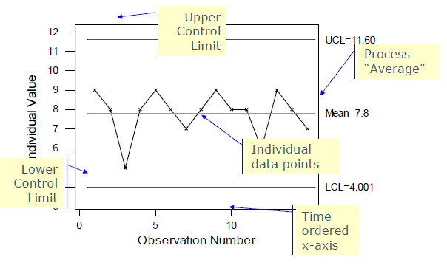
Figure 30: Key Features of a Control Chart

- Control Charts for Attributes
p-Charts for Proportion Defective
- p-chart: a statistical control chart that plots movement in the sample proportion defective (p) over time
c-Charts for Number of Defects Per Unit
- c-chart: a statistical control chart that plots movement in the number of defects per unit.
- Control Charts for Variables
- Two charts are used together: R-chart ("range chart") and X bar chart ("average chart")
- Both the process variability (measured by the R-chart) and the process average (measured by the X bar chart) must be in control before the process can be said to be in control.
- Process variability must be in control before the X bar chart can be developed because a measure of process variability is required to determine the -chart control limits.
- Other Types of Attribute-Sampling Plans
- Double-Sampling Plan: Specifies two sample sizes (n1 and n2) and two acceptance levels (c1 and c2)
1. If the first sample passes (actual defects c1), the lot is accepted
2. If the first sample fails and actual defects > c2, the lot is rejected
3. If first sample fails but c1 < actual defects c2, the second sample is taken and judged on the combined number of defectives found.
- Sequential-Sampling Plan: Each time an item is inspected, a decision is made whether to accept the lot, reject it, or continue sampling.
- Acceptance Sampling: To accept or reject a batch of items.
    - Frequently used to test incoming materials from suppliers or other parts of the organization prior to entry into the production process.
    - Used to determine whether to accept or reject a batch of products.
    - Measures number of defects in a sample. Based on the number of defects in the sample the batch is either accepted or rejected.
    - An acceptance level c is specified. If the number of defects in the sample is c the batch is accepted, otherwise it is rejected and subjected to 100% inspection.
- Control charts are used to:
  - Provide a simple, common language for discussing the behavior and performance of a process input or output measure
- Control the performance of a process by knowing when to take action and when not to
- Reduce the need for inspection
- Understand and predict process capability based on trends and other performance insights
- Determine whether changes made to the process are having the desired result
- Provide an ongoing, continual view of the performance of the process
- Create a repository of data for follow-on improvement activities.

3. Cost Savings Calculations
- The return on any investment compares the costs, or investment, over time to returns over time, discounted by a risk-adjusted rate to take into account the value of money over time. Due to the tremendous impact of Six Sigma, the most sensitive variable in this calculation is the returns, and not the costs.
- Returns can be segregated into hard and soft savings.
- Hard savings are those that are more easily traceable to actual cash, like reduced waste or headcount reductions. Hard savings calculations are pretty much the same from project to project and company to company.
- Soft savings are those that are less “bankable” like reductions in cycle times. There is tremendous room for interpretation with soft savings. Common and simple errors in calculating soft savings are things like counting gross sales improvements rather than the net from sales, or measuring working capital reductions rather than the reduced financing costs. But even with all the room for interpretations and mistakes in soft savings, not to develop an accepted methodology for assigning value would disregard a significant source of benefits.
- Whether hard or soft, one interesting observation is that few organizations calculating returns differentiate between one-time and recurring savings.
- Recurring savings obviously are worth a multiple of one-time savings and should be counted by calculating the present value of the related cash flows over the time period they recur. I think organizations don’t do this in the interest of being conservative, but they don’t realize how conservative it is.
- The greatest difficulty in measuring ROI in any performance improvement initiative is assigning value to non-cash-yielding improvements, like if the initiative boosts sales growth rates or advances the company’s competitive position.
- These kind of improvements can impact a company’s intrinsic value, thus creating shareholder value well in excess of any project savings. To assign value to such improvements, one must look to more sophisticated valuation theories such as Economic Value Analysis, which addresses shareholder value in a more significant way.
- With ROI as your objective, you have three variables with which to maximize it – lower the investment, raise the annual returns, or reduce the time in which gains are achieved. The most sensitive variable is raising targeted returns. Returns are a function of many interrelated variables. Some of these are the quality of the training event, the quality of the candidates, senior management support and the size of the opportunity. But the most sensitive variable is the selection of projects.
- The success of projects is most dependent on alignment to the company’s initiatives, assuming the initiatives have been correctly aligned to stakeholder concerns. In its simplest form, the initiative could be cost savings. Of course, once again, targeting strategic goals that redefine the company can have a much greater effect on the returns on an initiative.
- A good program will hit enough hard savings projects to achieve an acceptable ROI, move to goals with even greater impact, such as revenue projects that can change the company’s growth rate, and finally, move to goals aimed at redefining the company’s competitive position.
- The financial side of determining and using Cost saving can be related to the individual phases of DMAIC in the following manner:
- Define: Determine financial model and estimate financial impact
- Measure: Calculate current process cost and establish preliminary financial benefit targets
- Analyze: Refine the financial opportunity
- Improve: Perform cost-benefit analysis
- Control: Verify financial opportunity realized
- Realization: Track actual project performance for 12 months and validate financial benefits as part of control plan.

Costs | One-time | Annual
Current annual process cost  Improved annual process cost  Difference (savings) or cost |  | Rs.104,736  Rs .50,000  (Rs.54,736)
Cost to implement:  – Software upgrade (adjustment to ranger software)  – Training (28 hours x Rs.57 an hour)  Total cost to implement | Rs.2,000  Rs.1,596  Rs.3,596
Benefits | One-time | Annual
Annual process cost savings: soft savings from efficiency |  | (Rs.54,736)
Annual customer savings: reduce uplift (provide details on calculation and assumptions) |  | (Rs.30,000)
Other, non-quantifiable benefits  – Reduce risk to customers by increasing price certainty  – Increase customer satisfaction with collateral processing  – Improve organization reputation |  | N/A
Total Benefits |  | (Rs.84,736)
Net Cost/Benefit | Rs.3,596 | (Rs.84,736)
Table 7: Example of Cost-benefit Analysis

4. Control Plan
- A control plan is a written summary that describes what is needed to keep as improved process at its current level. This includes human resources and training requirements, actions that should be taken if measures are outside the specified range, and reactions needed to ensure process owners sustain the gains of process improvements.
- The intent of a process control plan is to control the product characteristics and the associated process variables to ensure capability (around the identified target or nominal) and stability of the product over time.
- The process Failure Modes and Effects Analysis (FMEA) is a document to identify the risks associated with something potentially going wrong (creating a defect – out of specification) in the production of the product. The FMEA identifies what controls are placed in the production process to catch any defects at various stages on the processing.
- Every completed Six Sigma project should have not only a control chart (if applicable), but a control plan. This ensures that the process doesn’t revert to the way it previously operated.
- A control plan lists all product and process inspection points required to deliver a defect-free outcome, and is essential for maintaining process control over the long run
- The purpose of the control plan is to ensure that performance improvements made by the project team are sustained over time. The plan is created during the improve phase of the define, measure, analyze, improve, control (DMAIC) approach or a similar phase of other methodologies.
- The project team should create the control plan along with the process owner and representation from all areas involved in the process. As the process changes or process knowledge increases and as measurement systems and implementation methods are evaluated and improved, the plan should be updated.
- A properly implemented control plan is critical to retain process improvement benefits. Benefits are:
- Provides a summary of process knowledge
- Keeps process requirements and expectations visible for all functional area involved
- Describes data used to assess process performance (process and/or quality indicators)
- Describes when action needs to occur, how frequently to check performance, who is responsible for checks, and what the contingency plans are
- Describes who is involved and what their roles are in the process
- How to Use a Control Plan
- Step 1. Briefly describe the process being performed.
- Step 2. Indicate the immediate benefactor of the process.
- Step 3. List the department and/or persons who either initiate or perform the process steps.
- Step 4. Show the process steps performed.
- Step 5. For the major steps of the process, determine the critical success factors and measures (e.g., time required to execute each step).
- Step 6. Indicate the negotiated needs and expectations with relevant quality indicators.
- Step 7. Develop control charts for selected control points and indicate control limits or any other metric to track performance over time (if control charts are not applicable).
- Step 8. List items that need to be checked, frequency, responsible person, and contingency plans when process necessitates.
- Step 9. List dates of changes and what changes were made.
- Step 10. List any other pertinent information needed.
- A well-made control plan in an organization helps avoid the negative business impact from process deterioration. A control plan can include steps that are needed to be timely undertaken when performance measures are not within a desired range. An organizational system needs to be in place so that process owners take ownership of the execution of a control plan for their area of the business.
- To enhance service quality, a control plan should be constructed by a designated team and the process owner. Over time, the plan should be updated depending on the evaluations after its implementation.

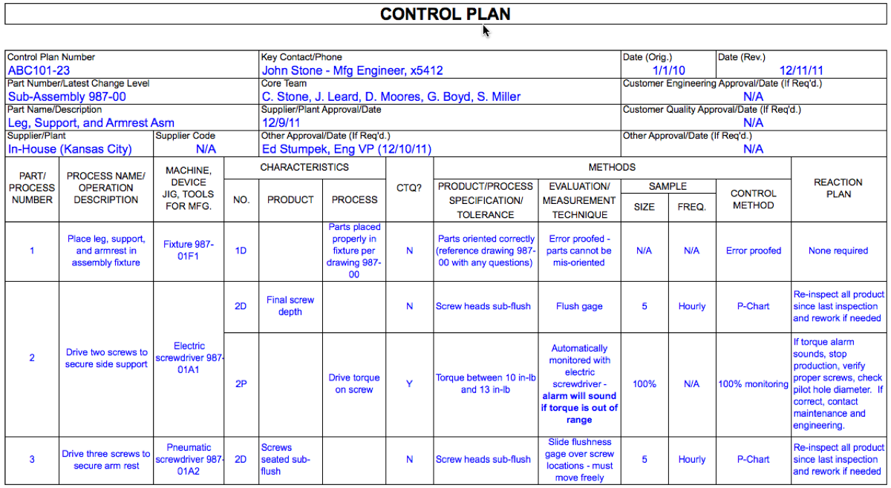 Figure 30: Sample Control Plan

After completing visiting the tools in the Control phase we now move on to the next part of this project - Recommendations, Conclusion and Bibliography.

Recommendations

The tools described in this project ‘Tools in Six Sigma – An Overview” are in accordance to the DMAIC phase. Many tools are available in Six Sigma Methodology - DMAIC (Define-Measure-Analyze-Improve-Control), DMADV (Define-Measure-Analyze-Design-Verify) and DFSS (Design For Six Sigma).

The scope of this project is limited to most frequently used tools in DMAIC (Define-Measure-Analyze-Improve-Control).33 tools are discussed above.
- The tools discussed in the Define phase are – Project Charter, Process Flowchart or Process Maps, SIPOC Diagram, Stakeholder Analysis, DMAIC Work Breakdown Structure, CTQ Definitions and Voice of the Customer
- The tools discussed in the Measure phase are – Process Flowchart or Process Map, Data Collection Plan/Example, Benchmarking, Measurement System Analysis/Gauge R&R, Voice of the Customer and Process Sigma Calculation
- The tools discussed in the Analyze phase are – Histogram, Pareto Chart, Run Chart , Scatter Plot, Regression Analysis, Cause and Effect/Fishbone Diagram and 5 Whys
- The tools discussed in the Improve phase are – Brainstorming, Mistake Proofing (Poka – Yoke), Design of Experiments, Pugh Matrix, QFD/House of Quality, Failure Modes and Effects Analysis (FMEA) and Simulation Software
- The tools discussed in the Control phase are – Process Sigma Calculation, Control Charts (Variable and Attribute), Cost Savings Calculations and Control Plan

Some tools are used throughout the actual project, like control plans, cause and effect diagrams, FMEA, process flow charts, voice of customer and many others. That is because new ideas may emerge anytime during the project, factors that were previously thought of as being a big impact to the process may eventually be proved otherwise. At each stage, returning to previous steps or methods, helps close off all possibilities and also allows the team to track the history of the project in a concise way.

The data collated, analyzed and interpreted for the tools discussed in this project, will help students, Six Sigma Practitioners (Six Sigma Green Belt aspirants), Project Managers and their teams, Quality team members, to understand and implement these tools.

By using these tools in the DMAIC process, one can improve any type of process in any organization, with a goal to improve efficiency and effectiveness, minimizing mistakes and maximizing values. These tools are used to drive quality improvements, within an organization, which is focused around the DMAIC model. Most of these tools are frequently used as quality methods that have been around for years together.

Improving the quality of goods and services by using the above tools, has been the single most important factor in increasing profits with emphasis on:
- Improving customer satisfaction
- Building market share
- Gaining competitive advantage and
- Sustainability in the market.

Future opportunity exists to discuss more tools used in DMAIC methodology. The other tools can be built on the foundation laid by this project. The businesses will go beyond their self-imposed boundaries to address many dimensions of a society desiring for the betterment of humankind.

Only limitation is that frequently used 33 tools under the DMAIC methodology of Six Sigma are discussed in this project.

CONCLUSION

In this project “Tools in Six Sigma – An Overview” I have discussed frequently used tools in Six Sigma DMAIC methodology. These tools existed decades ago, they still exist and they will be used in future with improvement.

In this project attempt has been made to discuss frequently used tools like a histogram, fish-bone diagram, Pareto and many alike. In the 33 tools discussed effort is primarily aimed at cost reductions by eliminating waste (scrap, inefficiencies, excess materials, rework, etc.) that increases cost but adds no value. These tools produce a financial benefit, either directly or indirectly, through cost reductions, revenue growth, balance sheet improvements or accomplishing strategic goals.

With the advancement of technology the effective implementation of the tools has been computerized (many software are available), there is no doubt that successful implementation of these tools has a future direction to progress. The tools will replace reactive habits with a dynamic, responsive, proactive style of management.

The tools used under DMAIC methodology, can be applied to any process. These tools bring together years of diverse process improvement techniques and data analysis, into a structured step by step format.

The aim is to measure defects and/or error rates; find and eliminate root causes to problems created by process and reduce the costs of products/services by eliminating defects. This also results in a more robust process that consistently achieves a higher standard of output –which is capable and in control!

“What gets managed, gets measured” – Peter Drucker.

Mapping this Project Report to Subjects Taught in PGDM – Operations Management
In this project, I have mapped and implemented the subjects learned for PGDM – Hybrid course. Principles of Management are followed while planning, organizing and decision making phases while documenting this project report as well as the presentation Financial Accounting and Cost Accounting are utilized for calculating the Process Sigma and Cost Saving tools. Managerial Economics is used while documenting the Simulation Software tool. Marketing Management and Strategic Management are effectively used in tools like – Stakeholder Analysis, Measurement System analysis, Regression Analysis, and FMEA Analysis.
HR Management, Fundamentals of Communication and Interview Preparation as well as Mastering Interviews and Networking skills are absorbed in Brainstorming and 5 Whys. Integration Management is effectively used while explaining Benchmarking and collating the different tools under DMAIC of Six Sigma. Innovation Management is utilized by explaining the different tools in easy, simple and understandable way tools like – Voice of Customer, Control Charts, World Class Manufacturing is applied while discussing Poka Yoke, Just-in-time; Project Management is used in tools - DMAIC WBS, Project Charter, Process flow; Production Planning and Control in tools like Design of Experiments and CTQ definitions while Production and Operations Management is used in tools like Pugh Matrix, Cause and Effect diagram/Fish Bone diagram.
Total Quality Management is applied to tools - Quality Function Deployment, Histogram, Scatter Plot, and Run Chart. Customer Centric Organization is applied to SIPOC Diagram, Control Plan, Radical Business Performance is used in the tool Data Collection Plan, while in the tool SIPOC diagram and Pareto emphasis has also been laid on Global Supply Chain Management. And Outsourced Manufacturing

Bibliography
- Internet Source/ Websites
- “Stability and linearity: Keys to an effective measurement system” on the site http://www.qualityadvisor.com/library/msa_stability_linearity.php
- Six Sigma Article at Wikipedia − A very good tutorial giving you overview about Six Sigma it’s at http://en.wikipedia.org/wiki/Six_Sigma
- Six Sigma − Motorola University : Motorola University is one of the best universities to provide different certifications for different levels of Six Sigma expertise it’s at http://www.motorola.com/motorolauniversity.jsp
- GE Six Sigma − GE Key Concepts of Six Sigma it’s at
- http://www.ge.com/en/company/companyinfo/quality/whatis.htm
- SigmaPro is a premier provider of Design for Six Sigma training, Lean Six Sigma training, and quality tools training. Please access for more information it at www.sigmapro.com
- iSixSigma.com, http://isixsigma.com/tools-templates
- “Quality Glossary,” Quality Progress, July 2002, p. 43.
- Yoji Akao, Quality Function Deployment: Integrating Customer Requirements Into Product Design, Productivity Press, 1990.
- The Quality Function Deployment Institute’s website, www.qfdi.org.
- Masao Kogure and Yoji Akao, “Quality Function Deployment and CWQC in Japan,” Quality Progress, October 1983, pp. 25-29.
- Jack B. ReVelle, John W. Moran and Charles A. Cox, The QFD Handbook, John Wiley and Sons, 1998.
- The International Technical Group’s website, www.iti-oh.com/cppd/qfd/qfd_basics. html
- Wheeler, Donald J., “Why We Keep Having 100-Year Floods,” Quality Digest, June 4, 2013, http://www.qualitydigest.com/inside/quality-insider-column/why-we-keep-having-100-year-floods.html, Accessed November 30, 2013.
- Stauffer, Rip, “Render Unto Enumerative Studies…,” Quality Digest, July 31, 2013, https://www.qualitydigest.com/inside/quality-insider-column/render-unto-enumerative-studies.html, Accessed November 30, 2013.
- LinkedIn, Six Sigma Network group, “How do we validate the samples taken would reflect the population parameter? Or how can we assure that we have taken the correct samples in a Six Sigma project?,” April 2013, https://www.linkedin.com/groupItem?view=&gid=42396&type=member&item=228657002&trk=groups_search_item_list-0-b-ttl&goback=%2Egna_42396, Accessed November 30, 2013.
- How Fleet Bank Fought Employee Flight, Harvard Business Review. http://hbr.org/2004/04/how-fleet-bank-fought-employee-flight/ar/1
- DOE Pro software at http://www.sixsigmaproductsgroup.com/Products/tabid/111/ProdID/23/Language/en-US/CatID/2/DOE_PRO_XL_SOFTWARE_ON_CD.aspx
- Stauffer, R. F. (July 2013). Render unto enumerative studies. Quality Digest Daily. 31 July 2013. Retrieved from http://www.qualitydigest.com/inside/quality-insider-column/render-unit-enumerative-studies.html
- Balestracci, D. (1998). Data “Sanity”: statistical thinking applied to everyday data. ASQ Statistics division Special Publication, Summer 1998, American Society for Quality. Retrieved from http://rube.asq.org/statistics/1998/06/data-sanity-statistical-thinking-applied-to-everyday-data.pdf
- Wheeler, Donald J., “Why We Keep Having 100-Year Floods,” Quality Digest, June 4, 2013, http://www.qualitydigest.com/inside/quality-insider-column/why-we-keep-having-100-year-floods.html, Accessed November 30, 2013.
- Stauffer, Rip, “Render Unto Enumerative Studies…,” Quality Digest, July 31, 2013, https://www.qualitydigest.com/inside/quality-insider-column/render-unto-enumerative-studies.html, Accessed November 30, 2013.
- www.pmi.org for the standard on Project Management - PMBOK – Project Management Book Of Knowledge – by PMI Project Management Institute.
- Books and References
- Montgomery, D. C., and G. C. Runger. “Gage Capability and Designed Experiments. Part I: Basic Methods.” Quality Engineering 6 (1993a): 115-135.
- Automotive Industry Action Group. Measurement System Analysis: Reference Manual, 3rd Edition. Southfield, MI: American Society for Quality Control, 2003.
- Engel, J., and B. De Vries. “Evaluating a well-known criterion for measurement precision.” Journal of Quality Technology 29 (1997): 469-476.
- Majeske, Karl D., and Chris Gearhart. “Approving Measurement Systems when Using Derived Values.” Quality Engineering 18 (2006): 523-532.
- A.I.A.G. (1991). “Statistical Process Control (SPC) Reference Manual,” Automotive Industry Action Group, Troy MI.
- William H. Woodall. (2000). “Controversies and Contradictions in Statistical Process Control, “Journal of Quality Technology, vol. 32, No. 4, pp. 341-350.
- Robert Hargrove, Mastering the Art of Creative Collaboration (McGraw-Hill, 1998) Peter Senge, The Fifth Discipline (Doubleday, 1990)
- Breyfogle, F., 1999. Implementing Six Sigma: Smarter Solutions Using Statistical Methods. 2nd ed. John Wiley & Sons
- Day, Ronald G., Quality Function Deployment: Linking a Company With Its Customers, ASQ Quality Press, 1993.
- 5. Castaneda-Mendez, Kicab, What’s Your Problem?, Taylor & Francis Group, 2013, Chapters 4-5.
- Shewhart, Walter A., Economic Control of Quality of Manufactured Product, American Society for Quality Control, 1981, p. 19.
- Deming, W. Edward, “On the Distinction between Enumerative and Analytic Surveys,” Journal of the American Statistical Association, Vol. 46, 1953, p. 245.
- Shewhart, Walter A., Economic Control of Quality of Manufactured Product, p. 148.
- Phadke, M.S., “Planning Efficient Software Tests,” CrossTalk Journal of Defense Software Engineering, October 1997, pp 11-15
- Phadke, M.S., Quality Engineering Using Robust Design. Prentice Hall, Englewood Cliff, NJ. November 1989.
- Taguchi, Genichi, System of Experimental Design, New York: UNIPUB/Krass International Publications, Volume 1 & 2, 1987.
- Browmlie, Robert; James Prowse; Madhav S. Phadke, “Robust Testing of AT&T PMX/StarMAIL using OATS,” AT&T Technical Journal, Volume 71, No. 3 May/June 1992, pp 41-47.
- Nancy R. Tague’s The Quality Toolbox, Second Edition, ASQ Quality Press, 2004, pages 351–356.
- Deming, W. E. (1950). Some Theory of Sampling, pp 502-503, New York, NY: John Wiley & Sons, Inc.
- Wheeler, D. J. (2005). The Six Sigma Practitioner’s Guide to Data Analysis. pp 1-11, Knoxville, TN: SPC Press.
- Quality Council of Indiana. The Certified Six Sigma Black Belt Primer, Second Edition, Quality Council of Indiana, West Terre Haute, Ind., 2012.
- Tubiak, T.M. and Benbow, Donald W. The Certified Six Sigma Black Belt Handbook, Second Edition, ASQ Quality Press, Milwaukee, Wisc., 2009.
- Wheeler, Donald J. and Chambers, David S. Understanding Statistical Process Control. SPC Press, Knoxville, Tenn., 1992.
- Minitab Version 16, “The process should be stable,” in Guidelines for Assistant>Hypothesis Tests>More.
- Castaneda-Mendez, Kicab, What’s Your Problem? Taylor & Francis Group, 2013, Chapters 4-5.
- Shewhart, Walter A., Economic Control of Quality of Manufactured Product, American Society for Quality Control, 1981, p. 19.
- Deming, W. Edward, “On the Distinction Between Enumerative and Analytic Surveys,” Journal of the American Statistical Association, Vol. 46, 1953, p. 245.
- Shewhart, Walter A., Economic Control of Quality of Manufactured Product, p. 148.
- Tukey, J. W. (1946). Review of Deming, W. E., Statistical Adjustment of Data, Review of Scientific Instruments, 17, pp. 152-153.
- Brue, G. Six Sigma for Managers. New York: McGraw-Hill, 2002.
- Duncan, A. J. Quality Control and Industrial Statistics. 5th ed. Homewood, Ill.: Irwin, 1986.
- Evans, James R., and William M. Lindsay. The Management and Control of Quality. 4th ed. Cincinnati: South-Western, 1999.
- Feigenbaum, A. V. Total Quality Control. New York: McGraw-Hill, 1991.
- Grant, E. L., and R. S. Leavenworth. Statistical Quality Control.6th ed. New York: McGraw Hill, 1998.
- Hoyer, R.W., and C. E.Wayne. “A Graphical Exploration of SPC, Part 1.” Quality Progress, 29, no. 5 (May 1996), 65-73.
- Juran, J. M., and F. M. Gryna. Quality Planning and Analysis. 2nd ed. New York: McGraw Hill, 1980.
- Wadsworth, H. M., K. S. Stephens, and A. B. Godfrey. Modern Methods for Quality Control and Improvement. New York: Wiley, 1986.
- Motorola Six Sigma Services. Motorola University. 22 July 2002.
- AlliedSignal Inc. 1998 Annual Report. Honeywell Inc. 22 July 2002.
- GE Investor Relations Annual Reports. General Electric Company. 22 July 2002.
- Honeywell Annual Reports. Honeywell Inc. 22 July 2002.
- Better Understand Six Sigma Plus With Honeywell’s Special PowerPoint Presentation. Honeywell Inc. 22 July 2002.
- Quality Digest, “Six Sigma at Ford Revisited,” June 2003, p. 30.
- The Six Sigma Way by Peter S. Pande, Robert P. Neuman & Roland R. Cavanagh.
- The Ultimate Six Sigma: Beyond Quality Excellence to Total Business Excellence by Bhote, Ketki R.
- Six Sigma Business Scorecard-2nd by Gupta, Praveen.
- Six Sigma Continual Improvement For Business: A Practical Guide by Truscott, William T.
- World Class Master Scheduling: Best Practices & Lean Six Sigma Continuous Improvement by Sheldon, Donald H.
- The Power of Six Sigma – An inspiring tale of how Six Sigma is transforming the way we work by Subir Chowdhury.
- Six Sigma for Dummies by Gygi, Craig, Decarlo Neil/Williams, Bruce. 8. Design for Six Sigma in Technology and Product Development by C. M.Creve ling, J. L. Slutsky & D. Antis, Jr.
--- < End of this Project Report> ---
THANK YOU.

